1.SOURCE SQL TO DESTINATION SQL IN IICS

CINEMA DATASE

Make connection to data source

Extract

Transform

Load to new target system - SQL Server

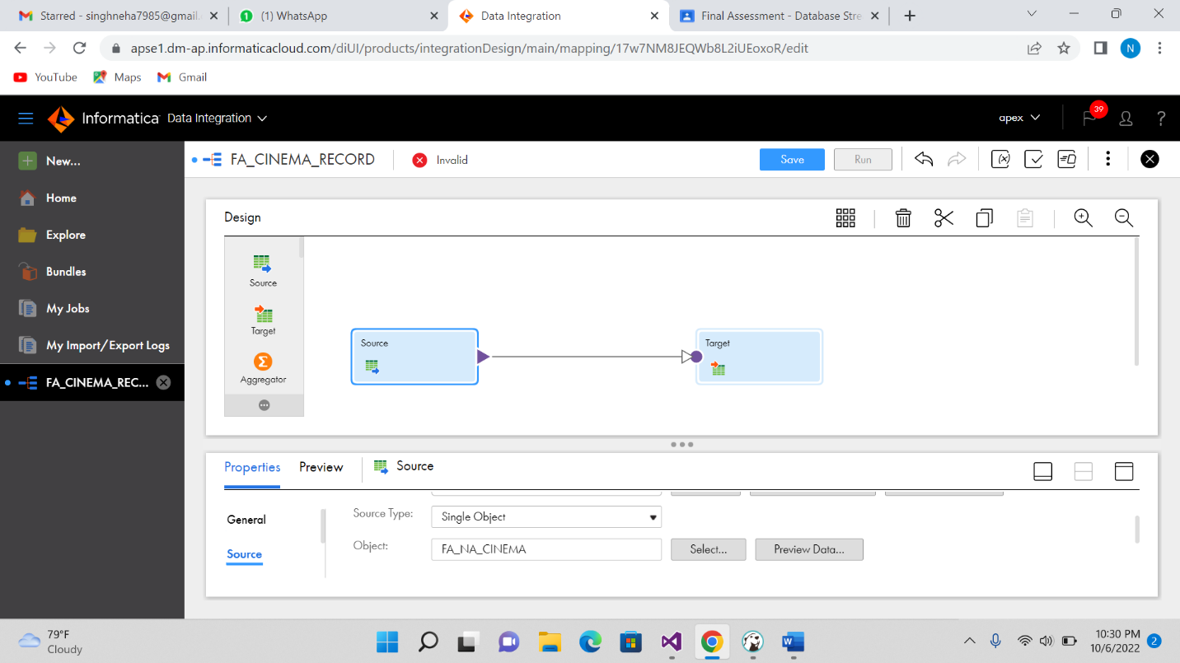

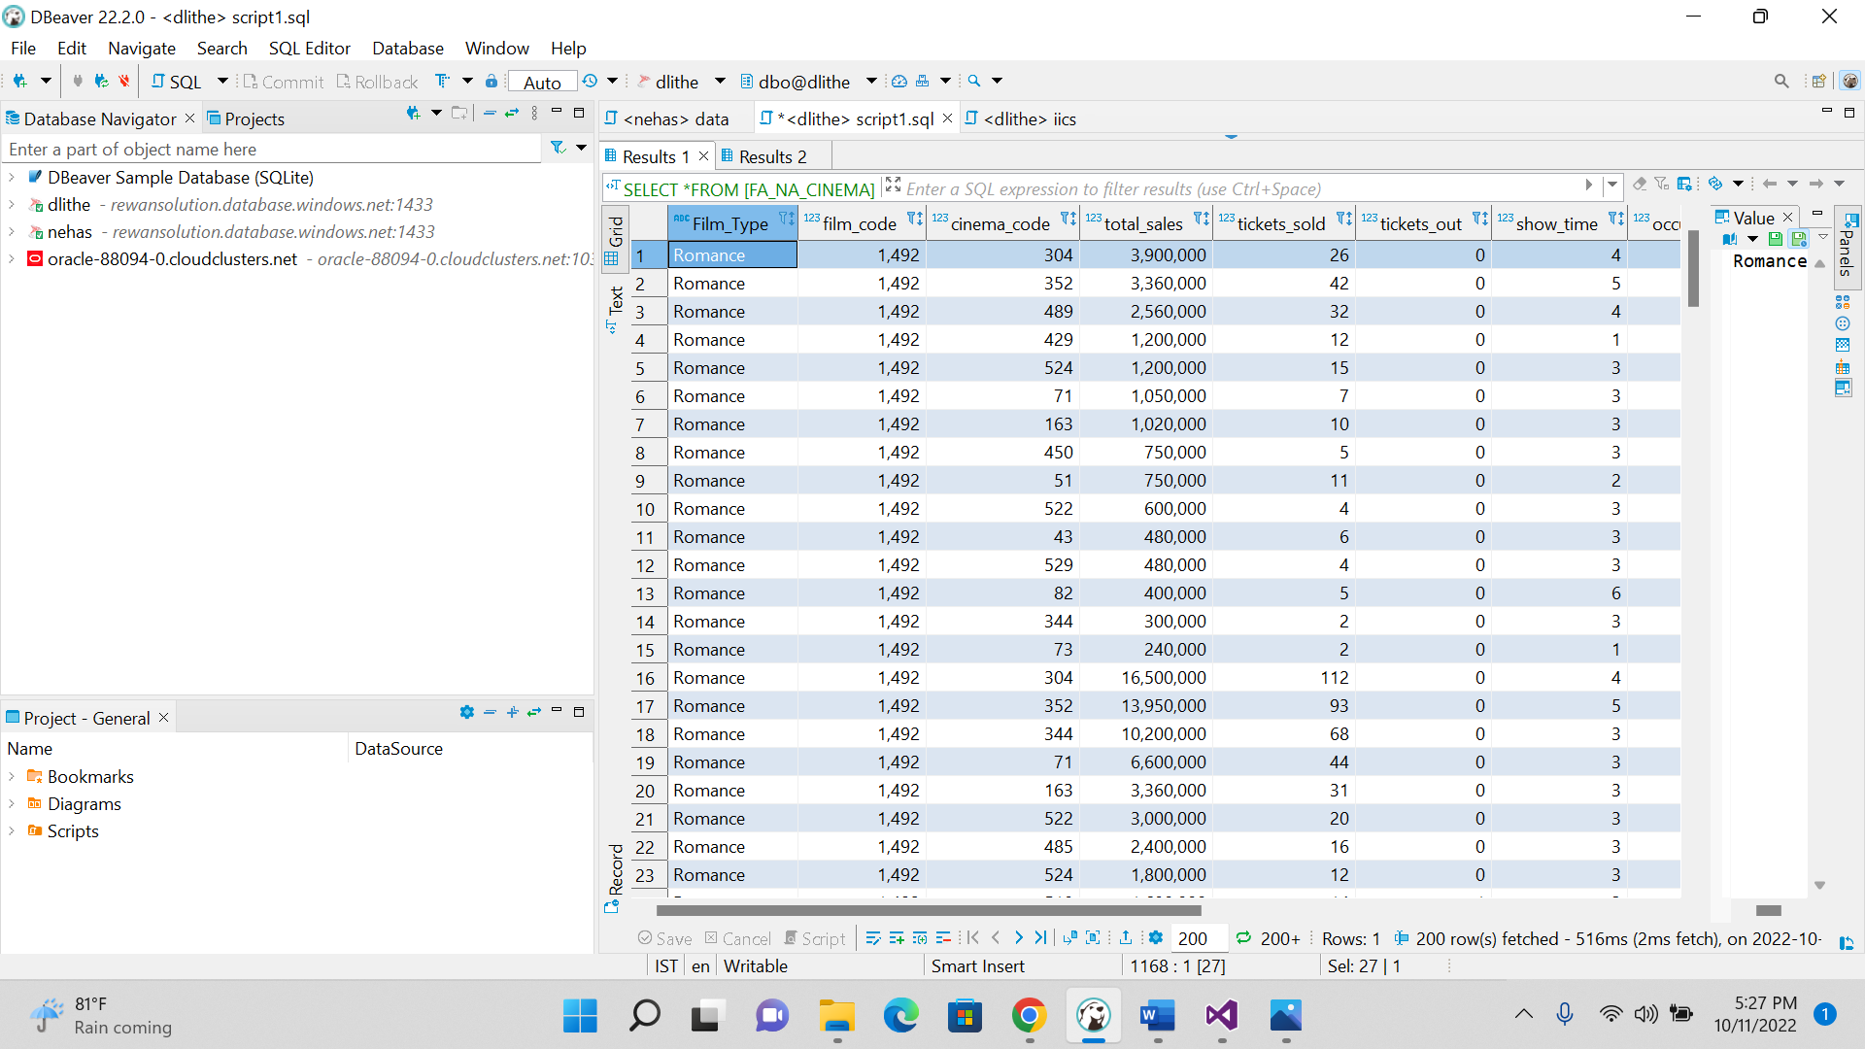

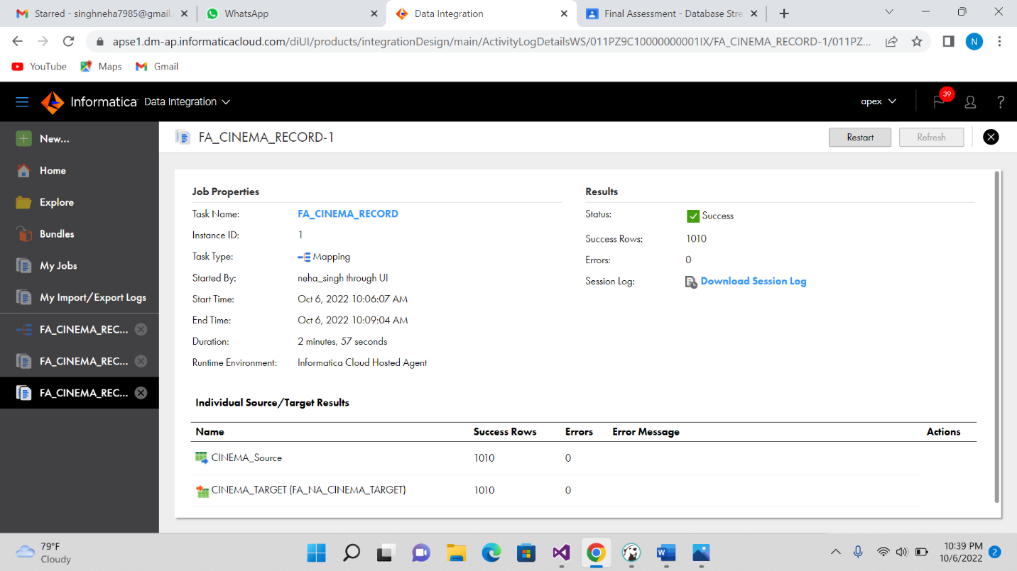

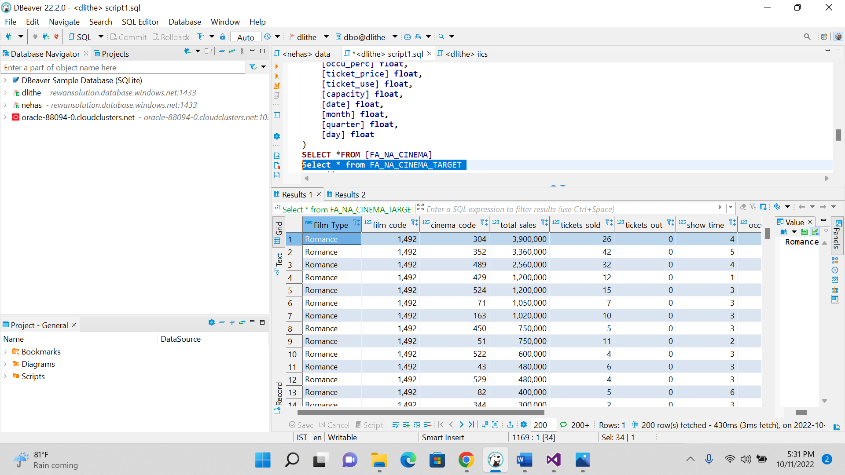

2 AGGREGATE FUNCTION IN IICS

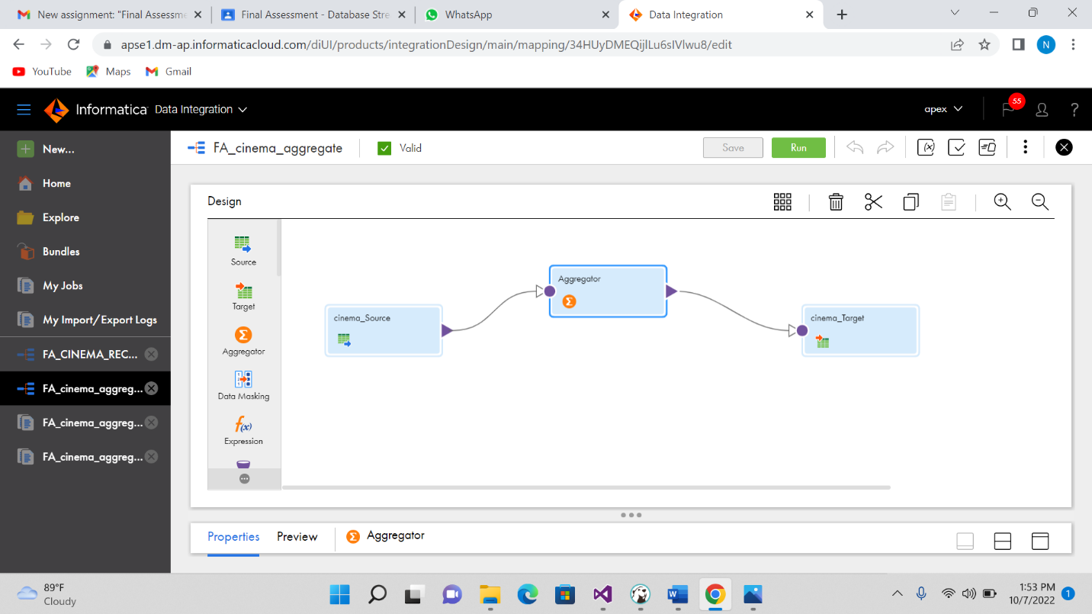

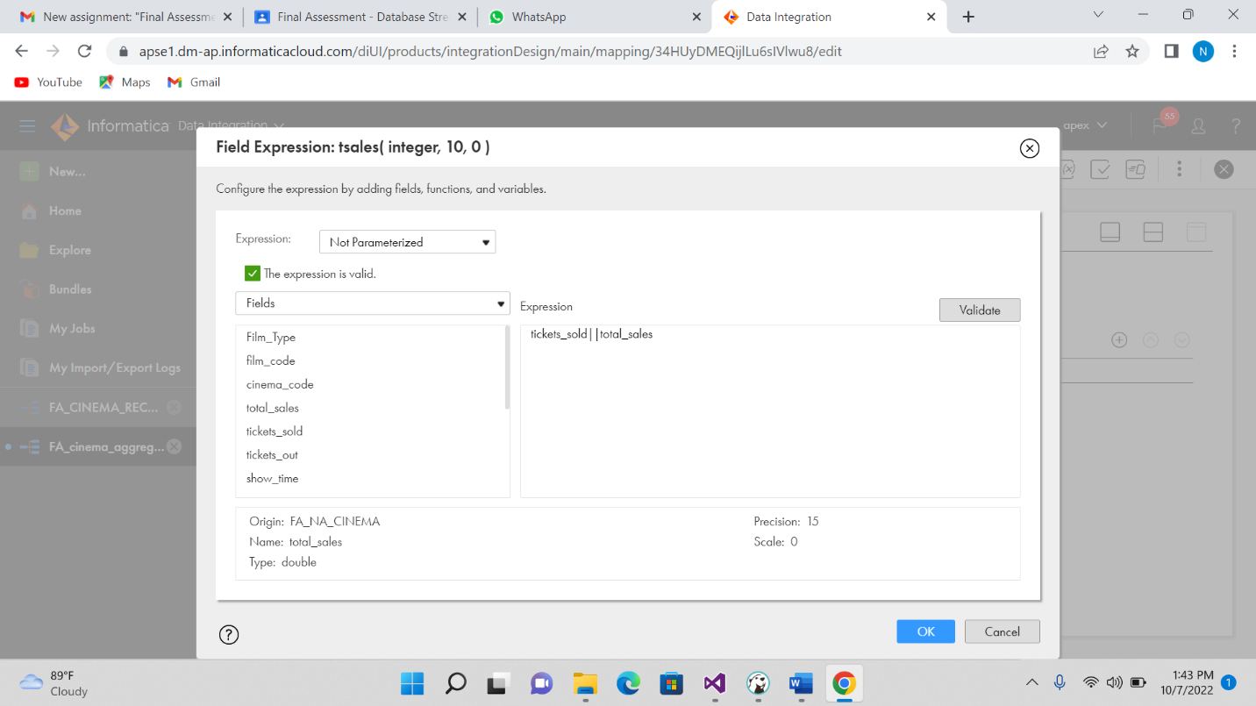

-----aggregate source table for iics-----

**CREATE** **TABLE** [FA_NA_CINEMA] (

[Film_Type] **nvarchar**(255),

[film_code] **float**,

[cinema_code] **float**,

[total_sales] **float**,

[tickets_sold] **float**,

[tickets_out] **float**,

[show_time] **float**,

[occu_perc] **float**,

[ticket_price] **float**,

[ticket_use] **float**,

[capacity] **float**,

[date] **float**,

[month] **float**,

[quarter] **float**,

[day] **float**

)

**SELECT** \***FROM** [FA_NA_CINEMA]

-----iics aggregate-------

**select** * **from** FA_cinema_sordata

output:

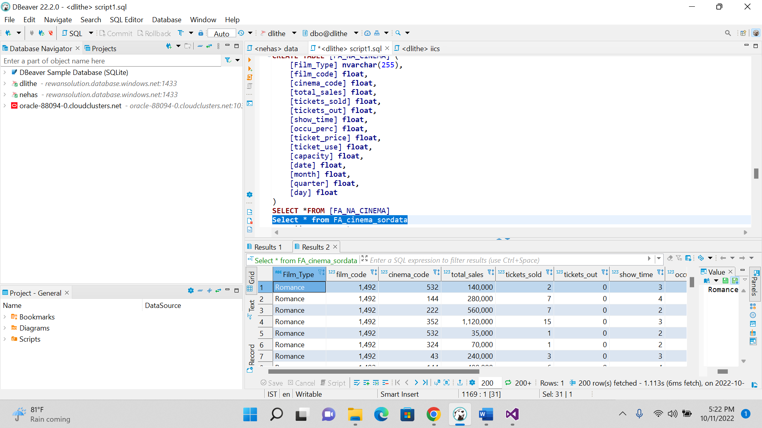

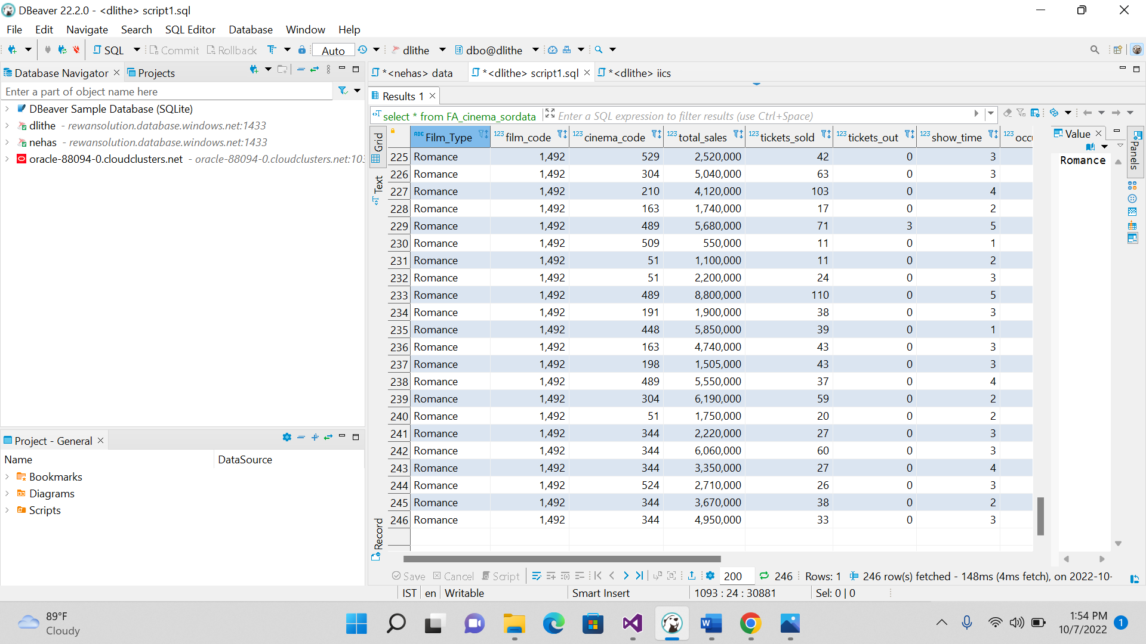

**Perform SCD 1 & SCD2 dimension table modelling**

-----SCD 1 FOR MODULE 4 IICS—

----DATASET CAR----FOR SCD1---

**CREATE** **TABLE** [FA_NA_CAR_SOURCE] (

[SupplierID] **float**,

[SupplierAddress] **nvarchar**(255),

[SupplierName] **nvarchar**(255),

[SupplierContactDetails] **nvarchar**(255),

[ProductID] **float**,

[CarMaker] **nvarchar**(255),

[CarModel] **nvarchar**(255),

[CarColor] **nvarchar**(255),

[CarModelYear] **float**,

[CarPrice] **float**,

[CustomerID] **nvarchar**(255),

[CustomerName] **nvarchar**(255),

[Gender] **nvarchar**(255),

[JobTitle] **nvarchar**(255),

[PhoneNumber] **nvarchar**(255),

[EmailAddress] **nvarchar**(255),

[City] **nvarchar**(255),

[Country] **nvarchar**(255),

[CountryCode] **nvarchar**(255),

[State] **nvarchar**(255),

[CustomerAddress] **nvarchar**(255),

[OrderDate] **float**,

[OrderID] **nvarchar**(255),

[ShipDate] **float**,

[ShipMode] **nvarchar**(255),

[Shipping] **nvarchar**(255),

[PostalCode] **float**,

[Sales] **float**,

[Quantity] **float**,

[Discount] **float**,

[CreditCardType] **nvarchar**(255),

[CreditCard] **float**,

[CustomerFeedback] **nvarchar**(255)

)

----DATASET CAR----FOR SCD1---

---TARGET FOR IICS SCD1----

**CREATE** **TABLE** [FA_NA_CAR_target] (

[SupplierID] **float**,

[SupplierAddress] **nvarchar**(255),

[SupplierName] **nvarchar**(255),

[SupplierContactDetails] **nvarchar**(255),

[ProductID] **float**,

[CarMaker] **nvarchar**(255),

[CarModel] **nvarchar**(255),

[CarColor] **nvarchar**(255),

[CarModelYear] **float**,

[CarPrice] **float**,

[CustomerID] **nvarchar**(255),

[CustomerName] **nvarchar**(255),

[Gender] **nvarchar**(255),

[JobTitle] **nvarchar**(255),

[PhoneNumber] **nvarchar**(255),

[EmailAddress] **nvarchar**(255),

[City] **nvarchar**(255),

[Country] **nvarchar**(255),

[CountryCode] **nvarchar**(255),

[State] **nvarchar**(255),

[CustomerAddress] **nvarchar**(255),

[OrderDate] **float**,

[OrderID] **nvarchar**(255),

[ShipDate] **float**,

[ShipMode] **nvarchar**(255),

[Shipping] **nvarchar**(255),

[PostalCode] **float**,

[Sales] **float**,

[Quantity] **float**,

[Discount] **float**,

[CreditCardType] **nvarchar**(255),

[CreditCard] **float**,

[CustomerFeedback] **nvarchar**(255)

)

**select** * **from** [FA_NA_CAR_target]

**alter** **table** [FA_NA_CAR_target]

**add** checksum_tar **varchar**(20)

**alter** **table** [FA_NA_CAR_target]

**drop** **column** check_sum

**UPDATE** FA_NA_CAR_SOURCE

**set** SupplierName ='nehasingh'

**where** SupplierID=1

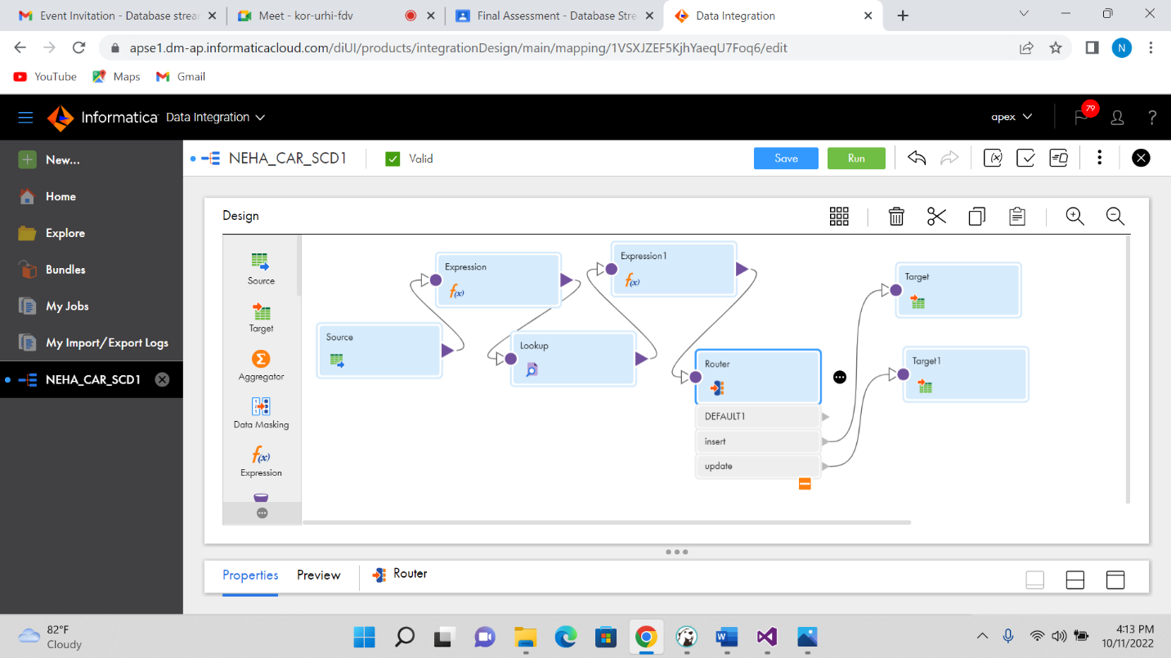

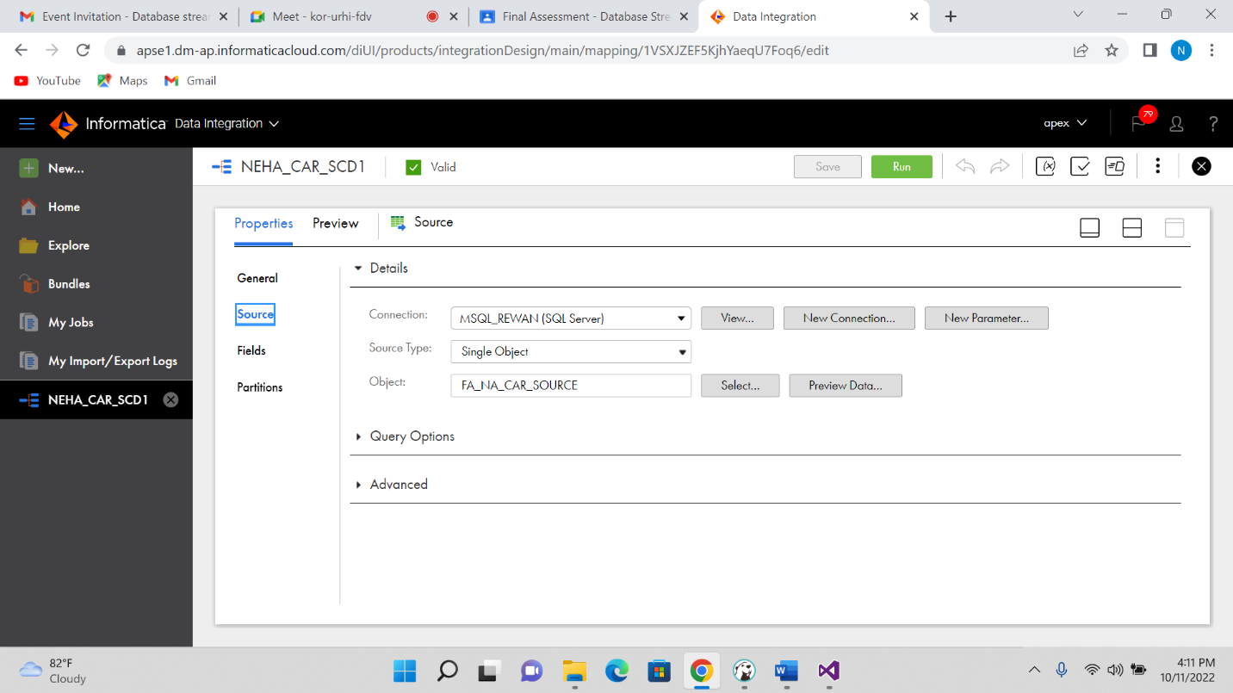

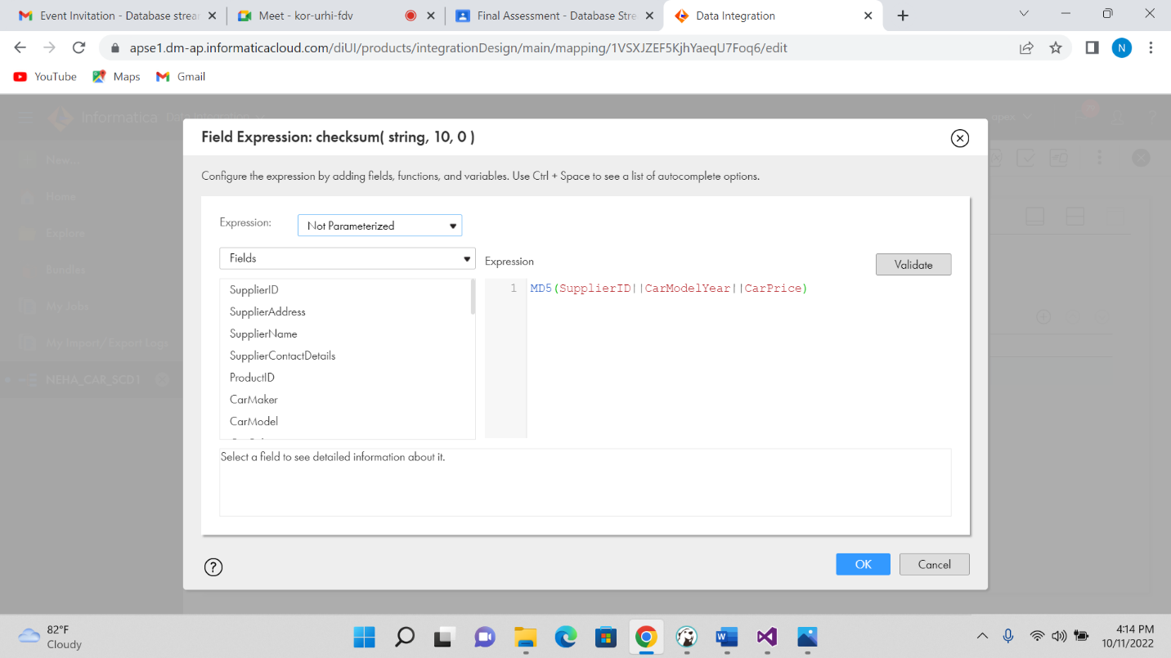

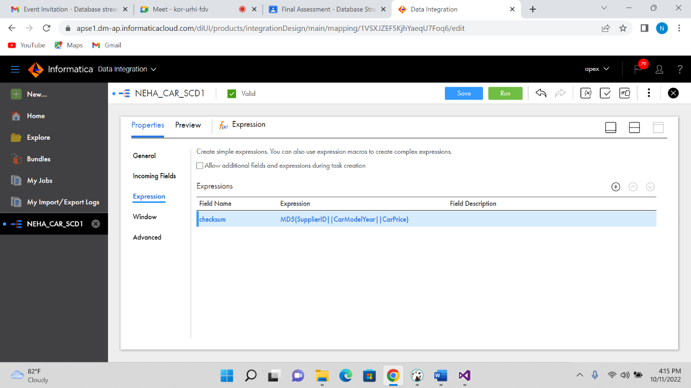

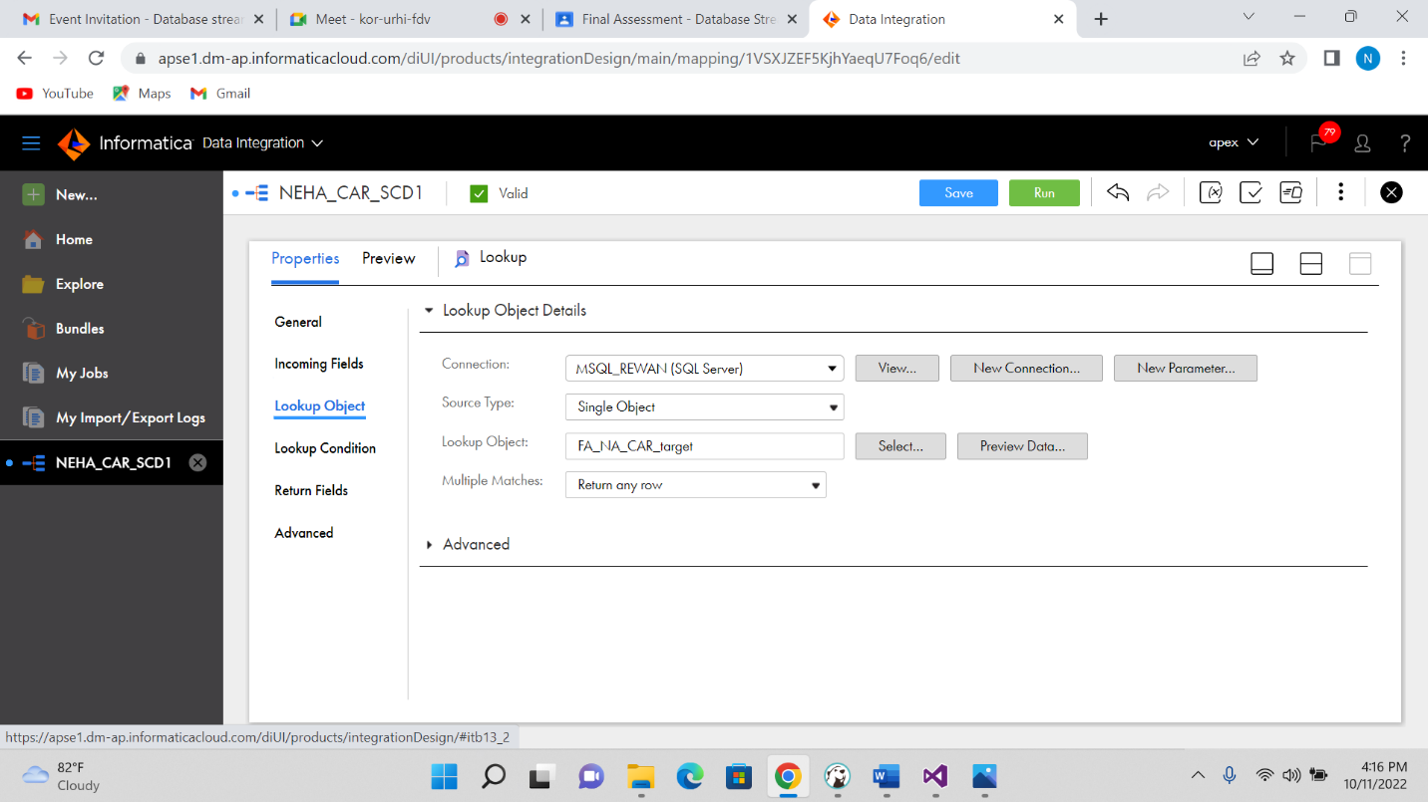

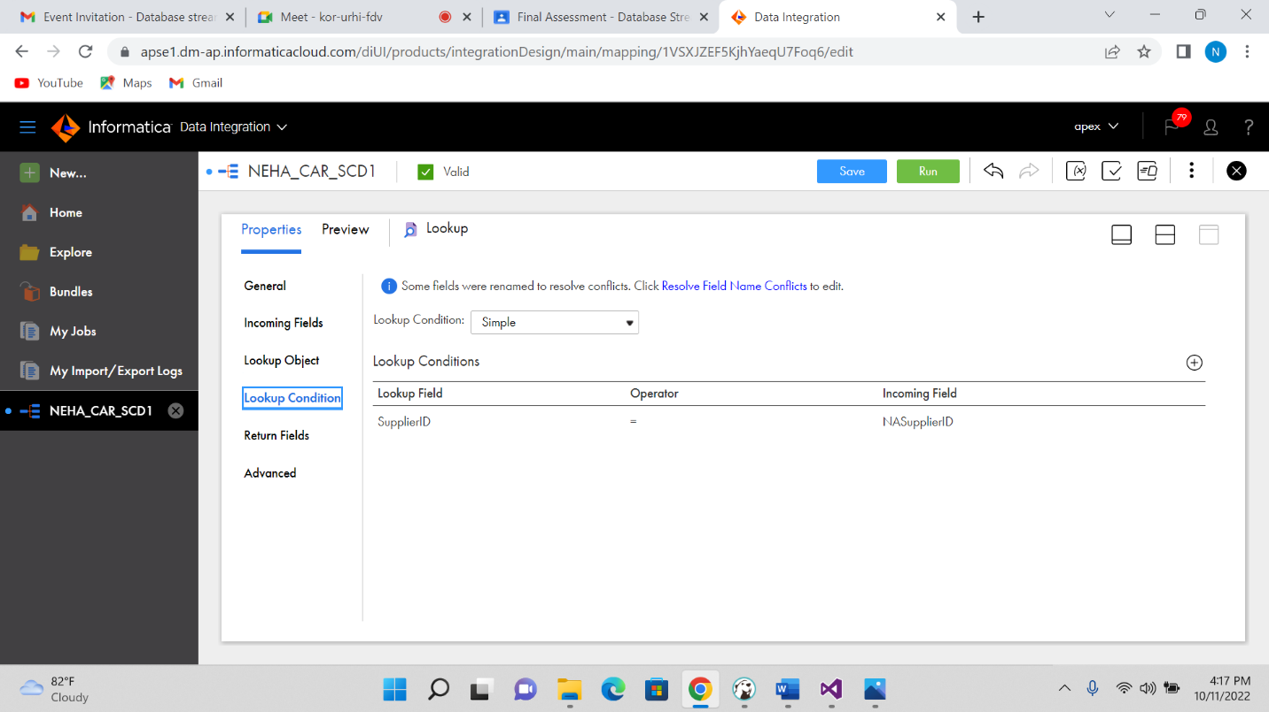

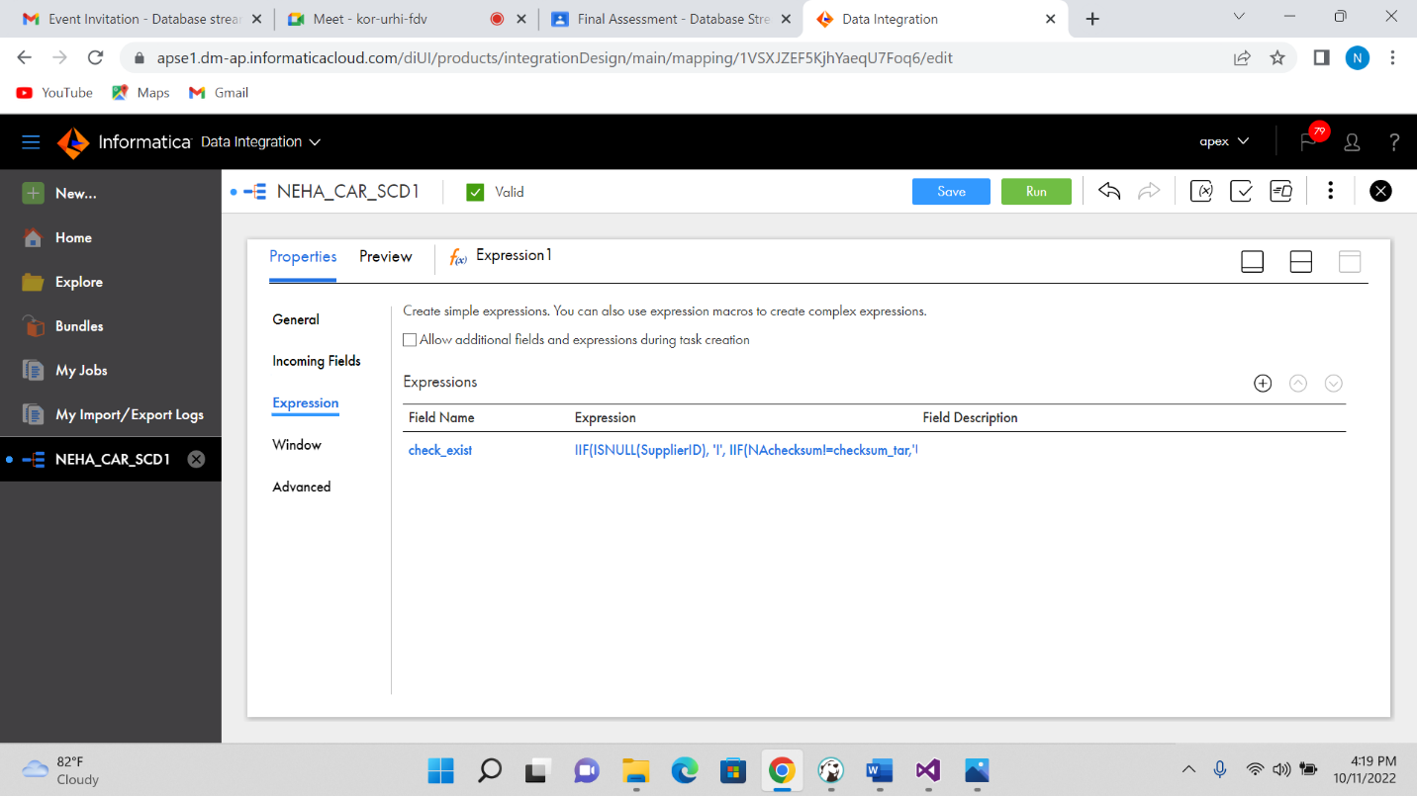

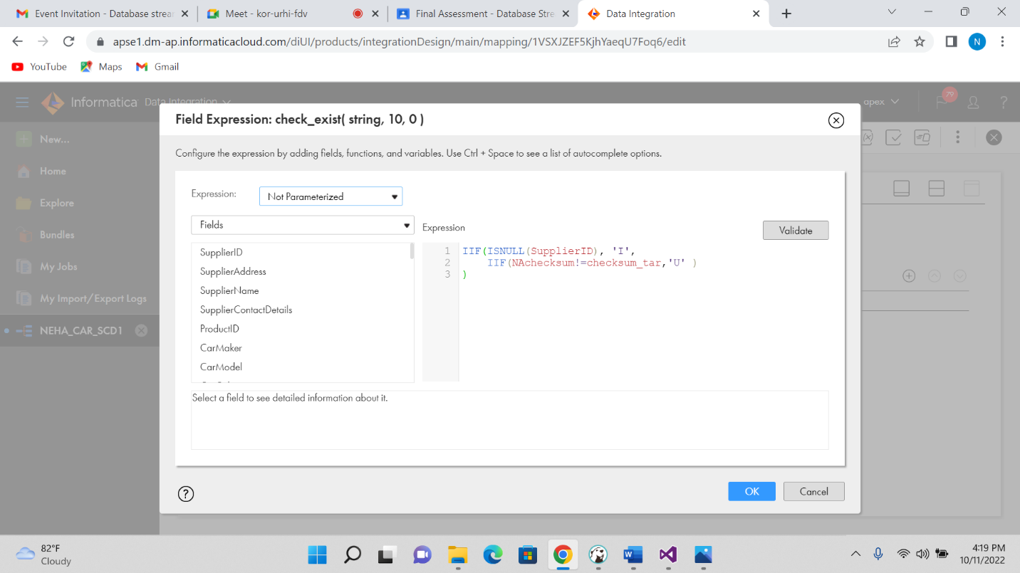

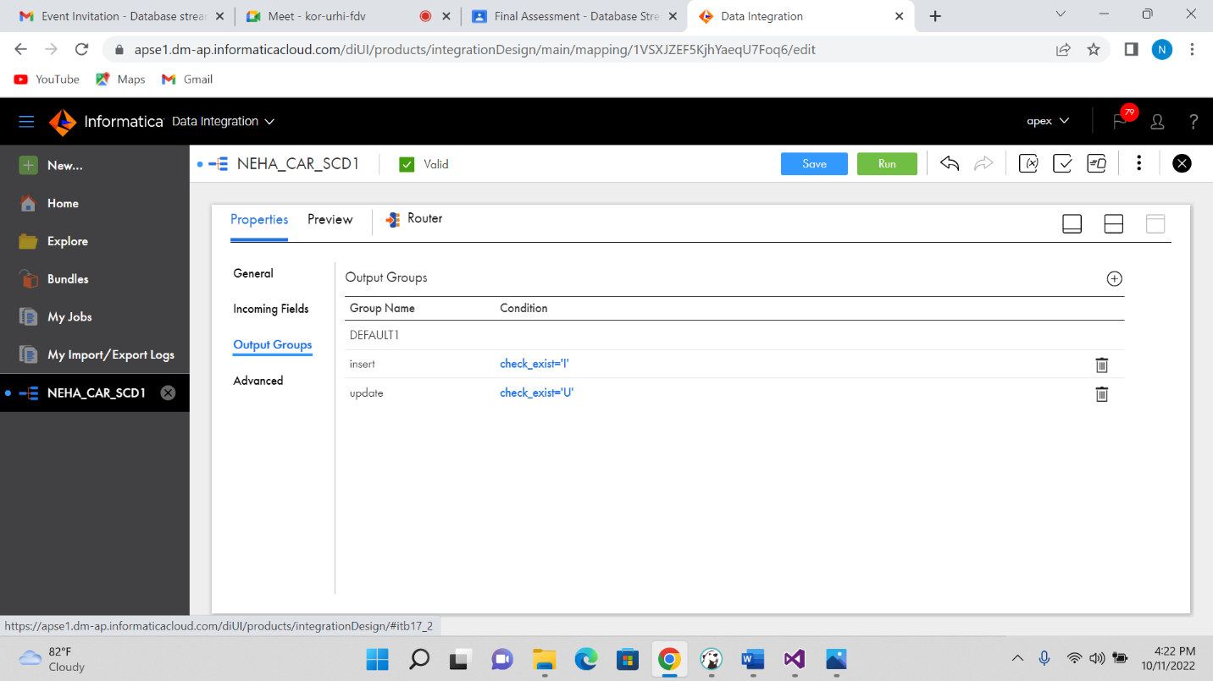

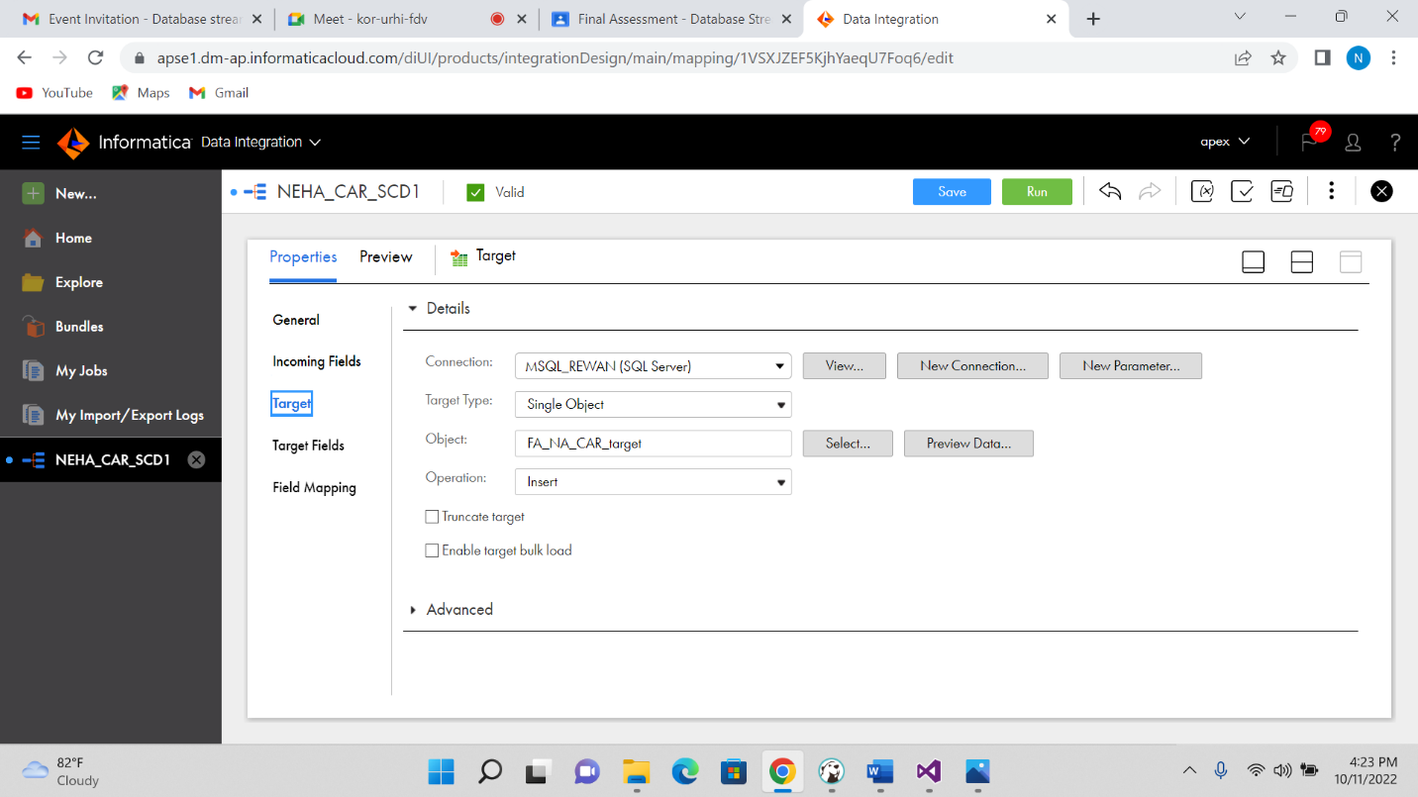

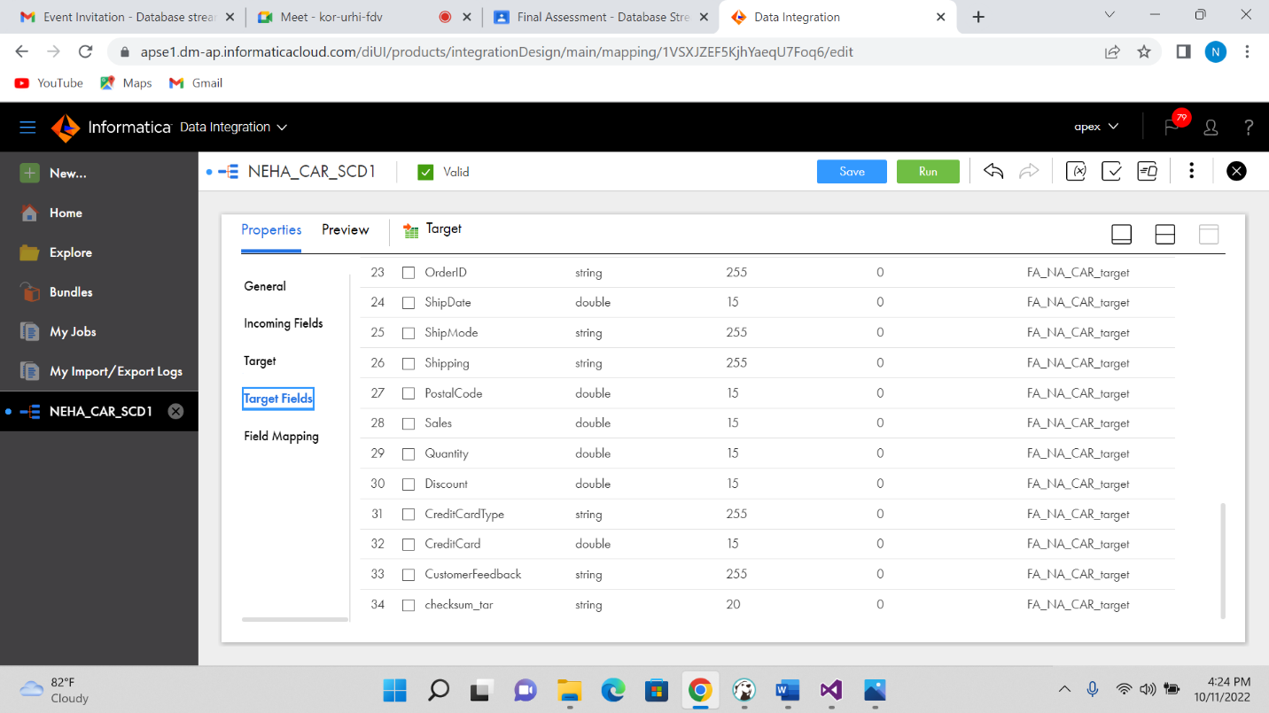

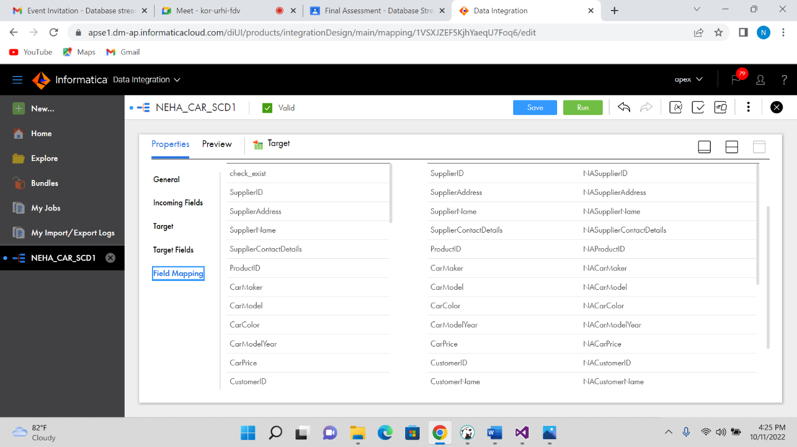

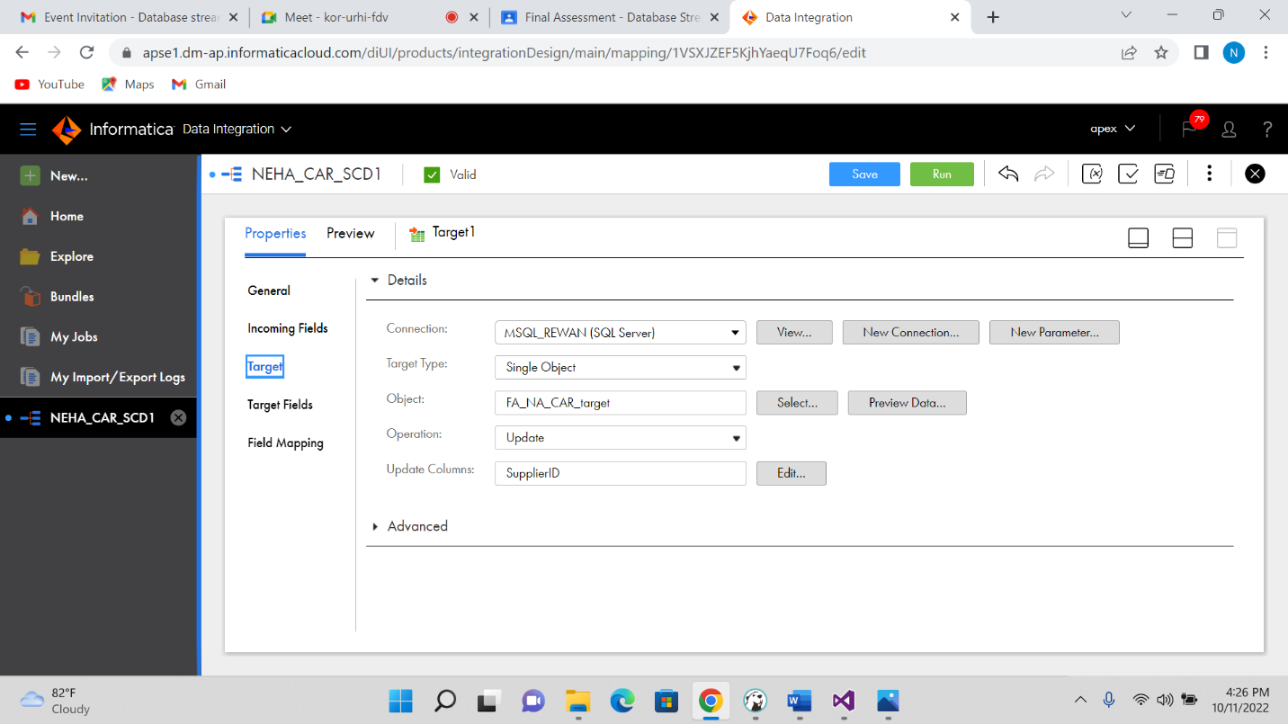

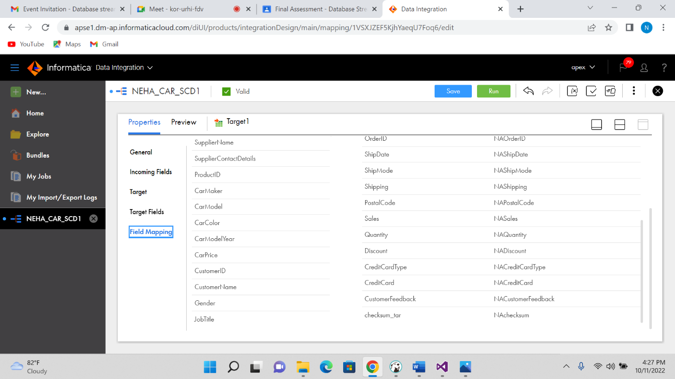

Output:

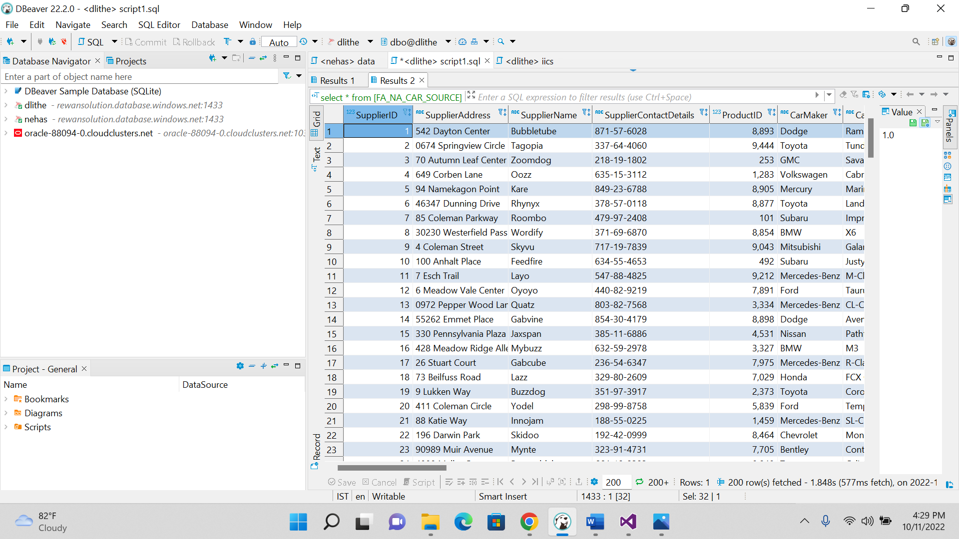

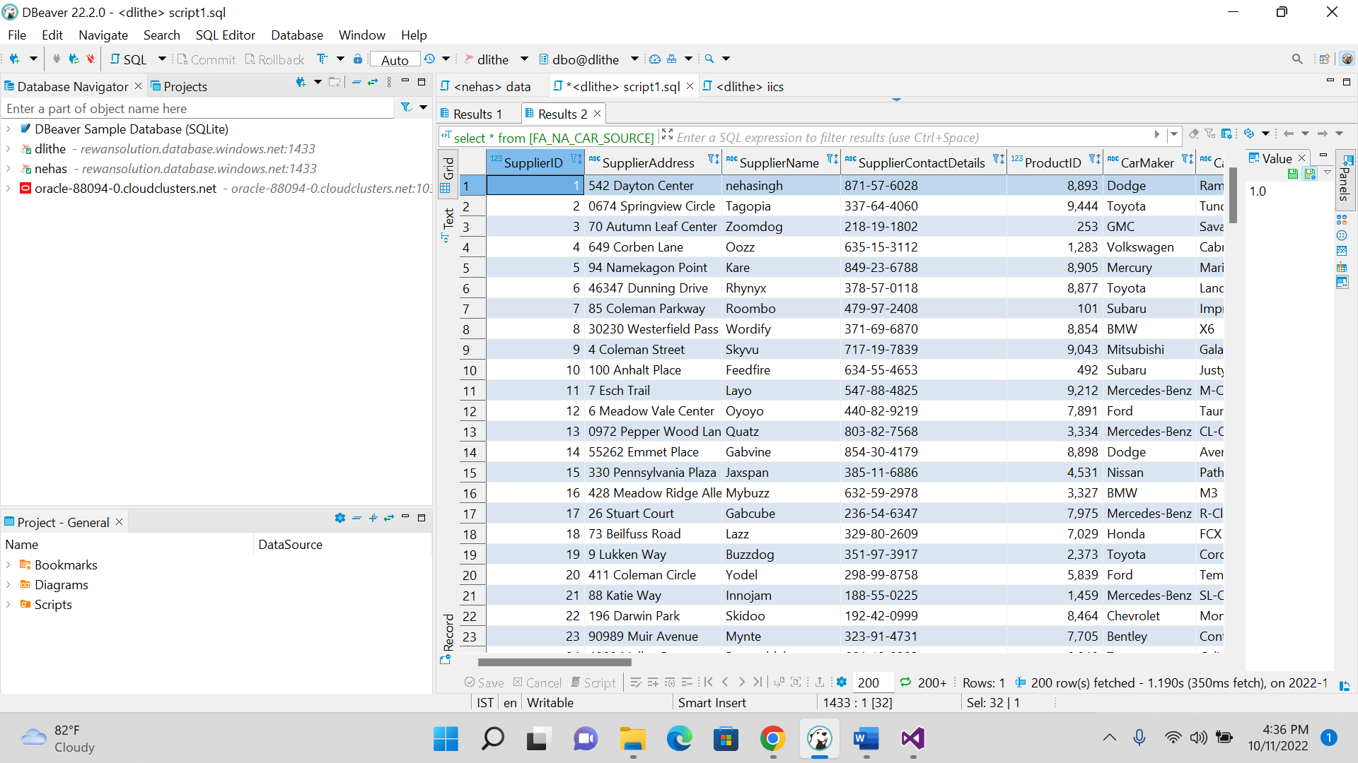

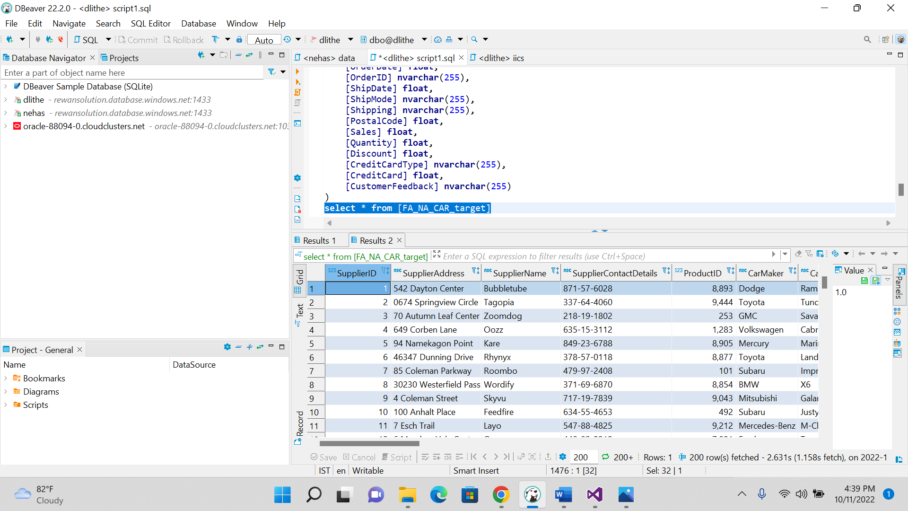

----**SCD2** FOR MODULE 4 IICS-----

---HEALTH DATA--

**create** **table** TE_FA_HEALTH_SCD2_SRC

(

PID **float**,

CATEGORY_NAME **nvarchar**(255),

HOSP_NAME **nvarchar**(255),

PREAUTH_AMT **float**,

CLAIM_AMOUNT **float**

)

**UPDATE** TE_FA_HEALTH_SCD2_SRC

**set** CATEGORY_NAME ='ONCOLOGY'

**where** PID='11'

**INSERT** **INTO** TE_FA_HEALTH_SCD2_SRC **values**(1,'NEPHROLOGY','Rims Govt.General Hospital,Srikakulam,',12567,11000)

**INSERT** **INTO** TE_FA_HEALTH_SCD2_SRC **values**(2,'NEPHROLOGY','Rims Govt.General Hospital,Srikakulam,',12000,12000)

**INSERT** **INTO** TE_FA_HEALTH_SCD2_SRC **values**(3,'NEPHROLOGY','Rims Govt.General Hospital,Srikakulam,',12900,13000)

**INSERT** **INTO** TE_FA_HEALTH_SCD2_SRC **values**(4,'NEPHROLOGY','Rims Govt.General Hospital,Srikakulam,',12500,11000)

**INSERT** **INTO** TE_FA_HEALTH_SCD2_SRC **values**(5,'NEPHROLOGY','Rims Govt.General Hospital,Srikakulam,',12678,11000)

**INSERT** **INTO** TE_FA_HEALTH_SCD2_SRC **values**(6,'NEPHROLOGY','Rims Govt.General Hospital,Srikakulam,',12567,11000)

**INSERT** **INTO** TE_FA_HEALTH_SCD2_SRC **values**(7,'NEPHROLOGY','Rims Govt.General Hospital,Srikakulam,',12567,11000)

**INSERT** **INTO** TE_FA_HEALTH_SCD2_SRC **values**(8,'CARDIC ','Karumuri Hospital',15000,15678)

**INSERT** **INTO** TE_FA_HEALTH_SCD2_SRC **values**(9,'CARDIC ','AREA Hospital',15000,15678)

**INSERT** **INTO** TE_FA_HEALTH_SCD2_SRC **values**(10,'CARDIC ',' RAM Hospital',16000,15678)

-----DESTINATION--

**CREATE** **TABLE** TE_FA_HEALTH_SCD2_TGT

(

patient_key **float**,

patient_id **float**,

catg_name **nvarchar**(255),

hospital_name **nvarchar**(255),

start_date **date**,

end_date **date**,

checksum **nvarchar**(255)

)

**select**\* **from** TE_FA_HEALTH_SCD2_TGT

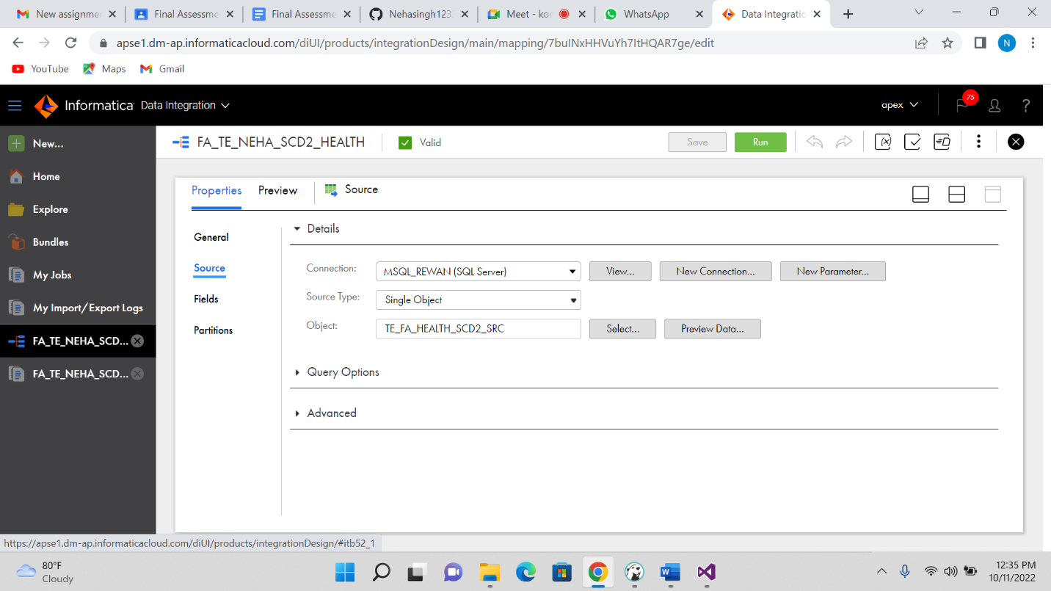

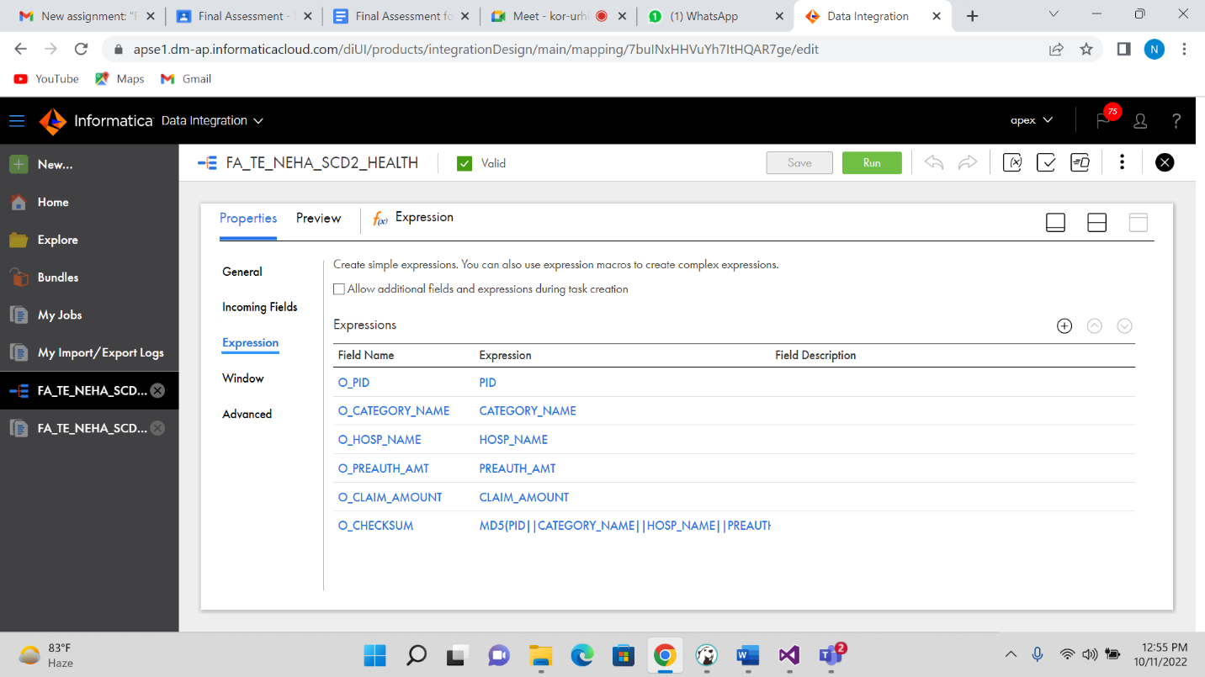

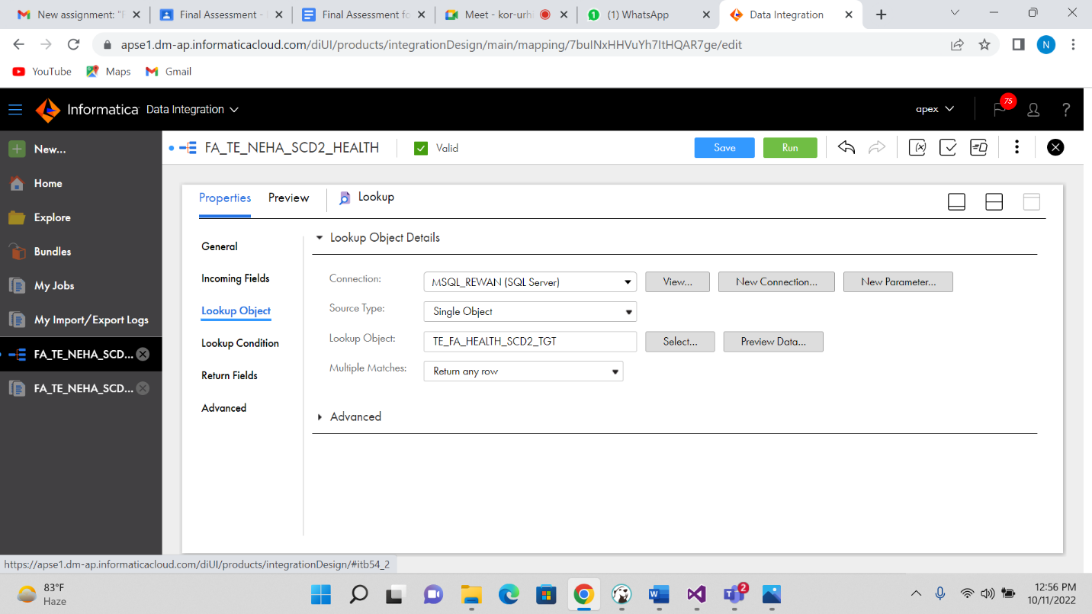

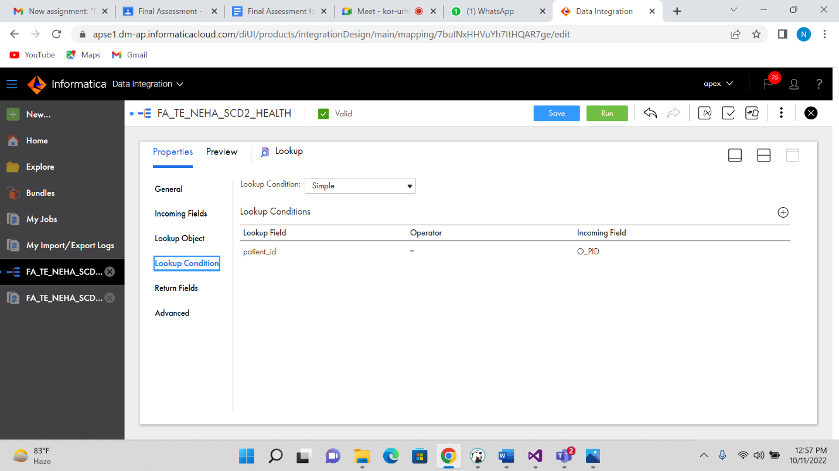

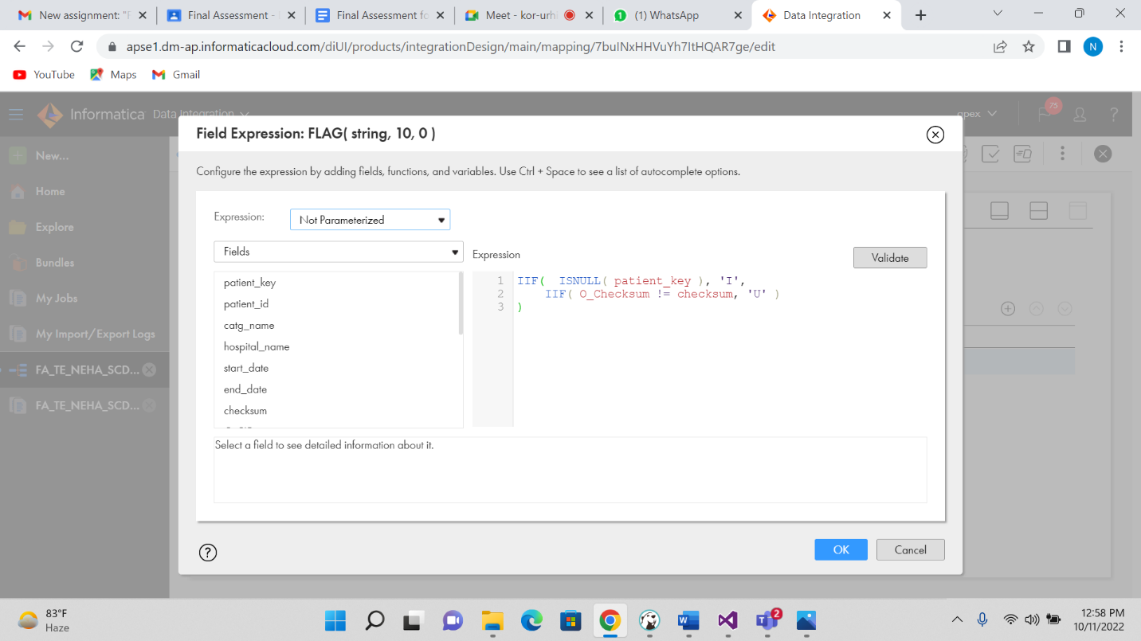

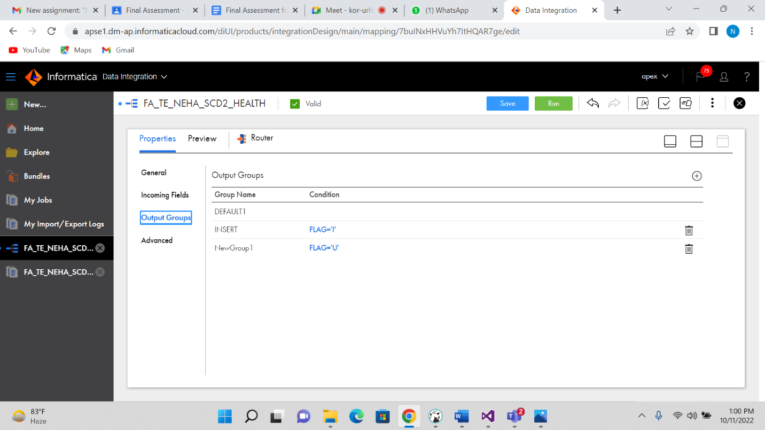

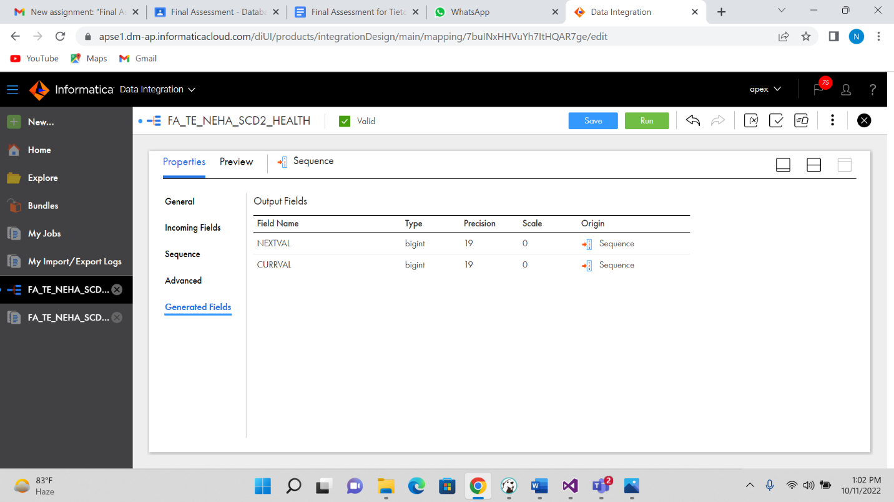

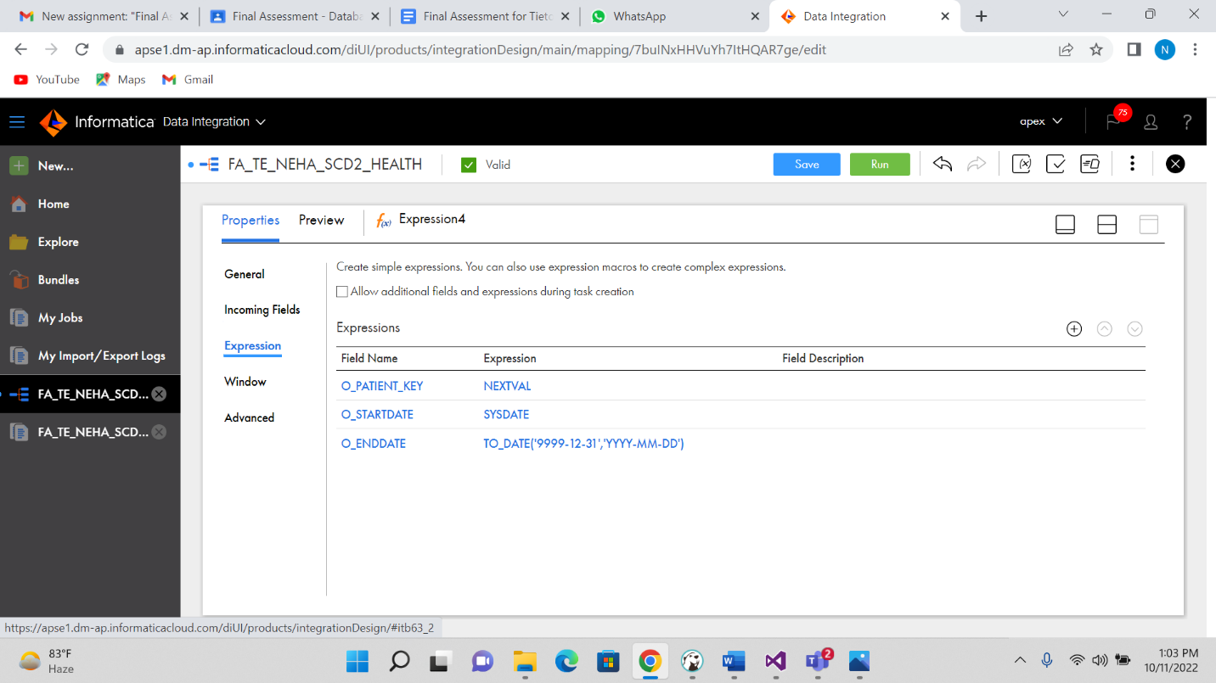

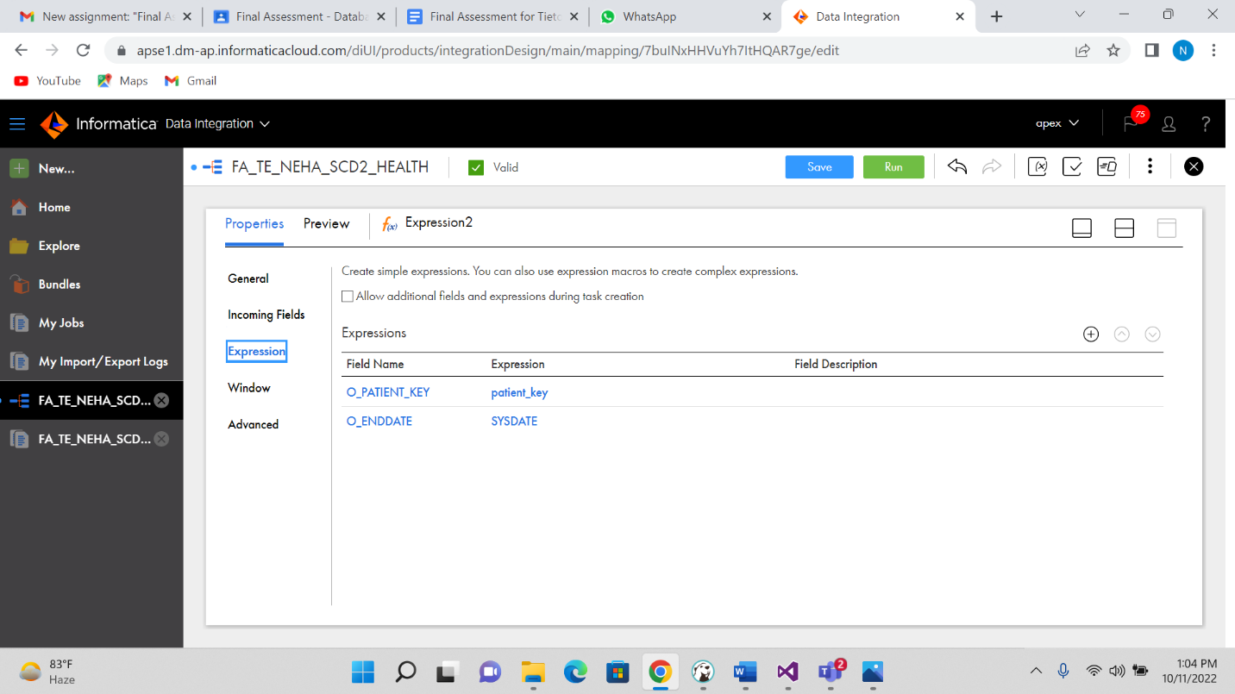

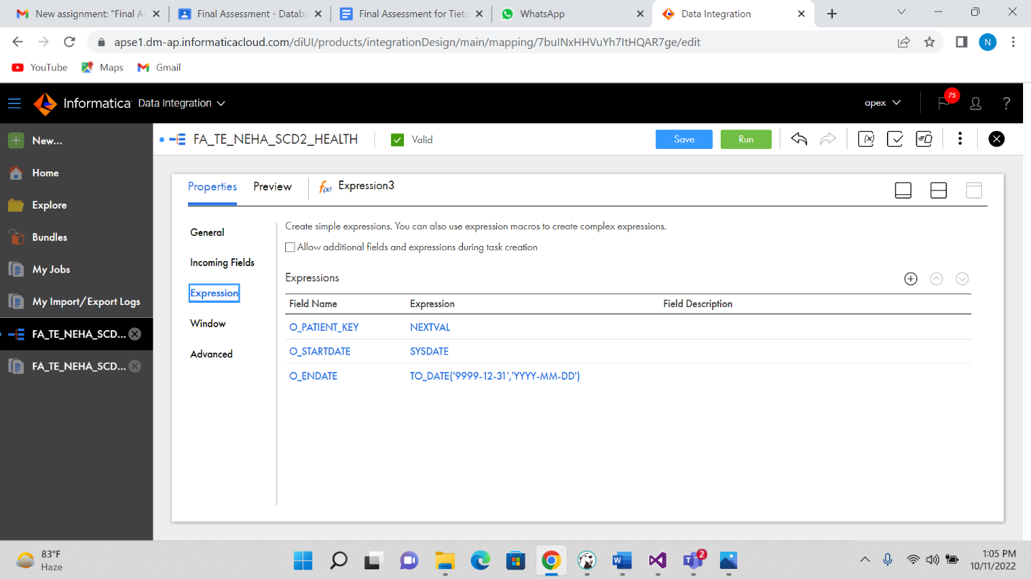

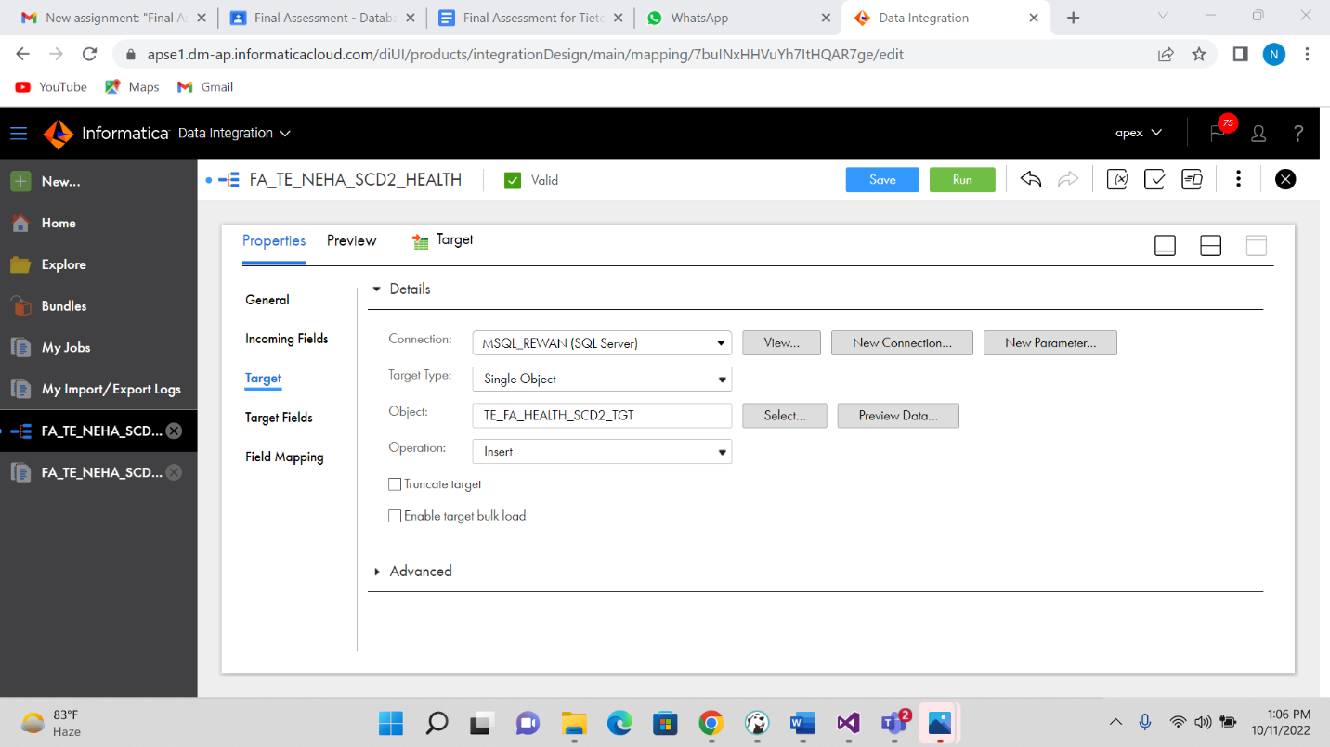

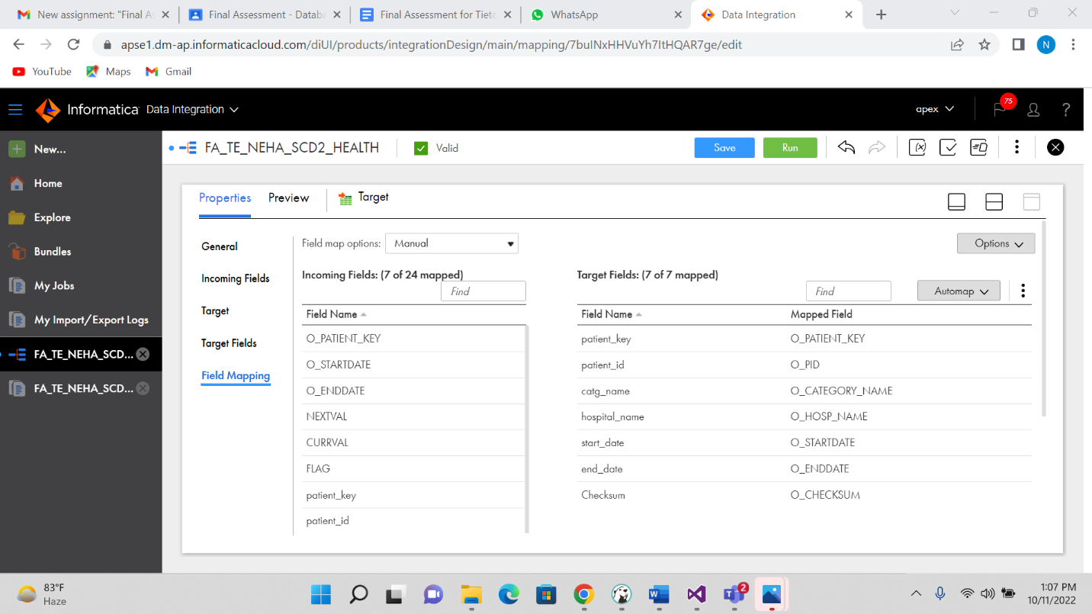

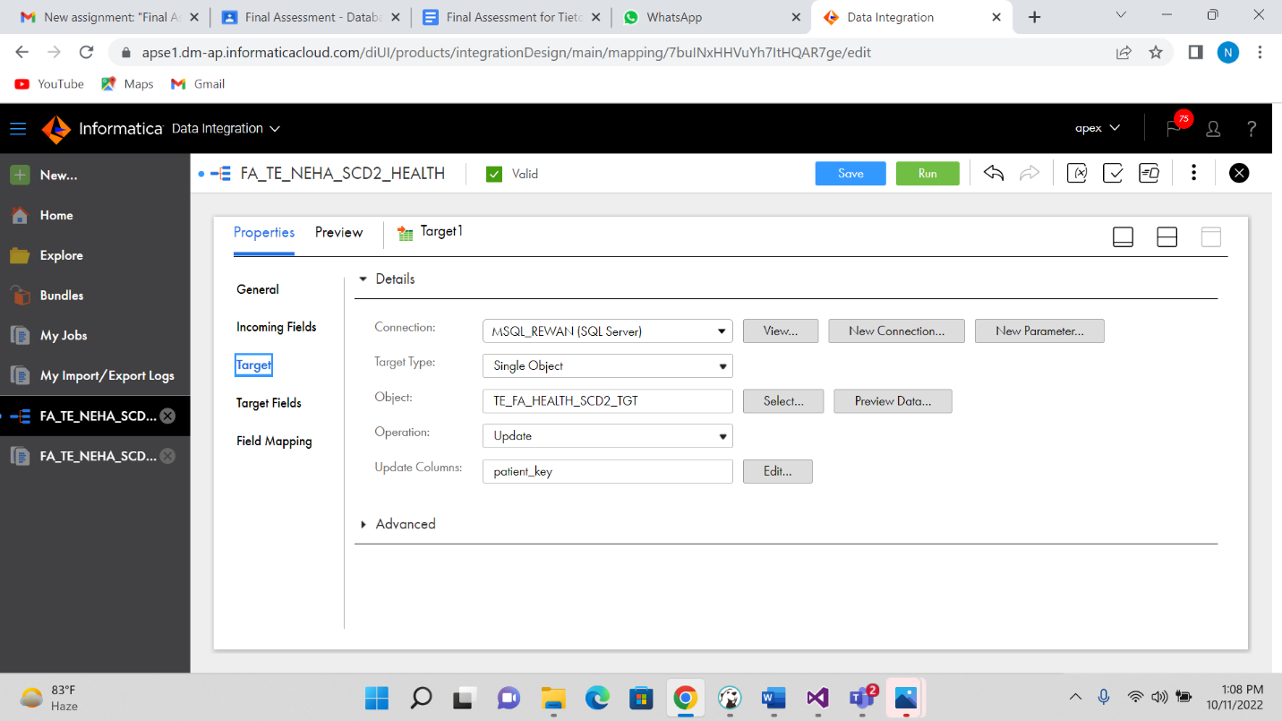

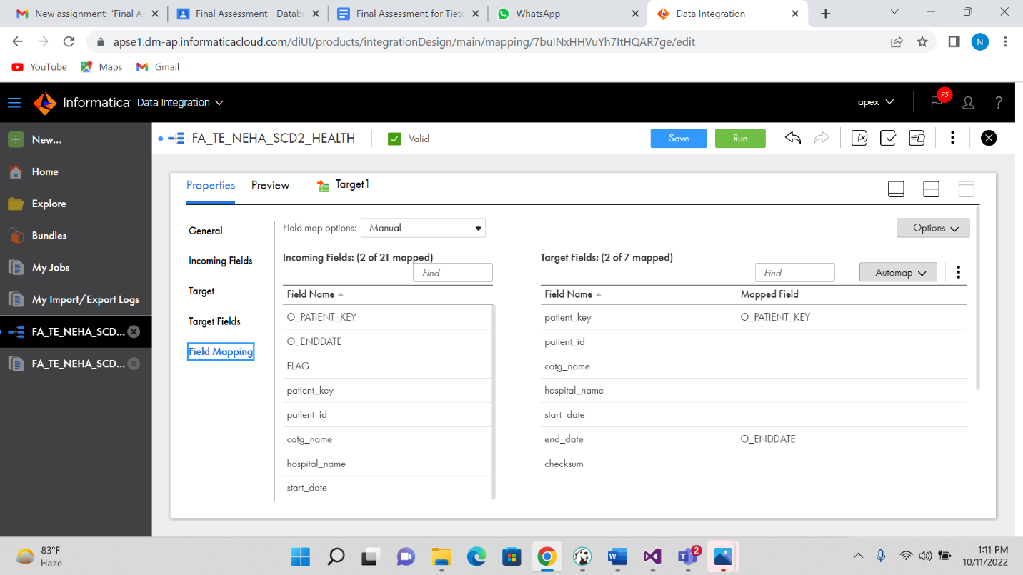

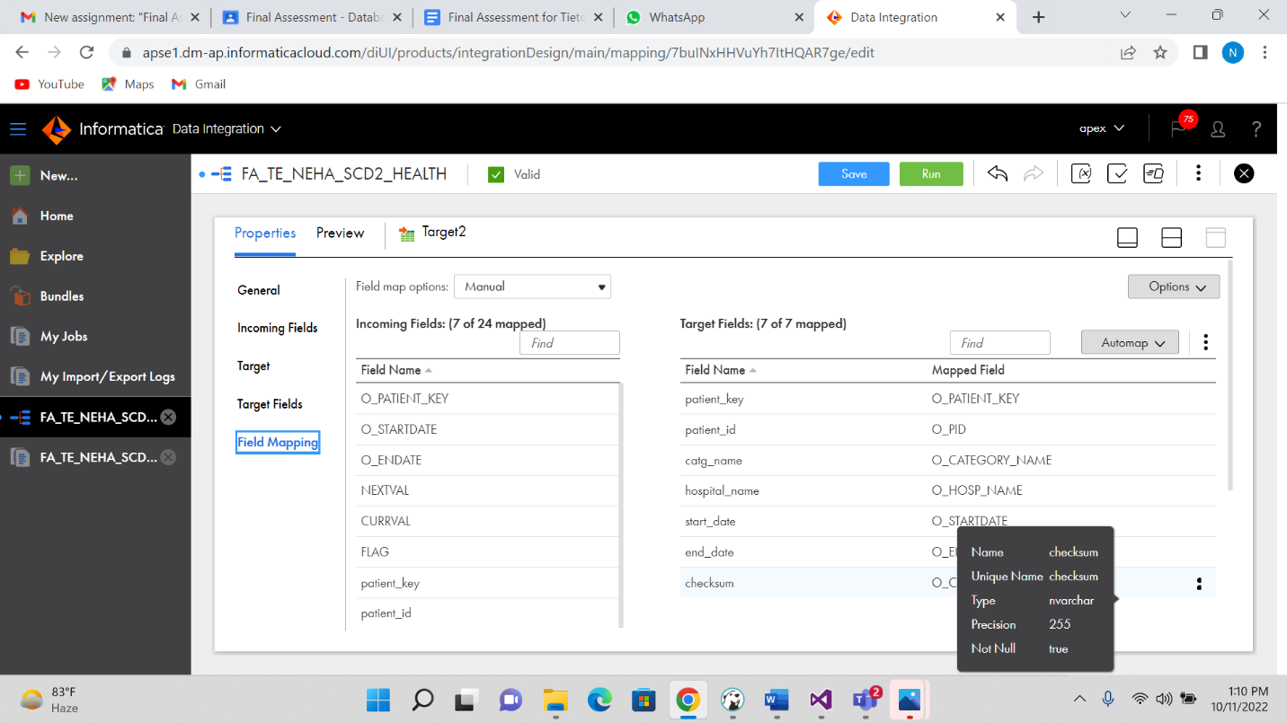

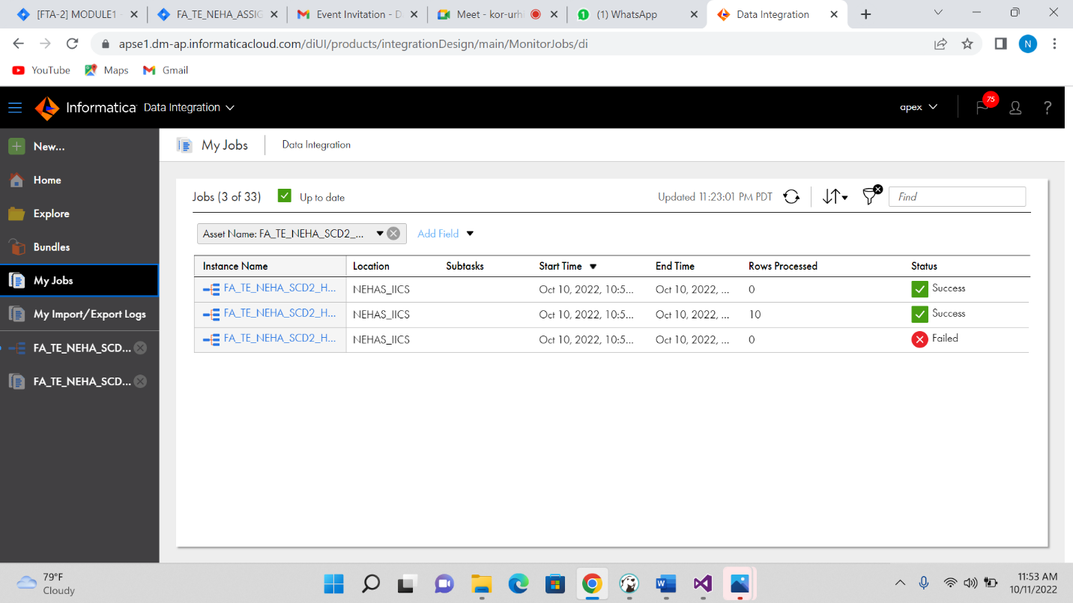

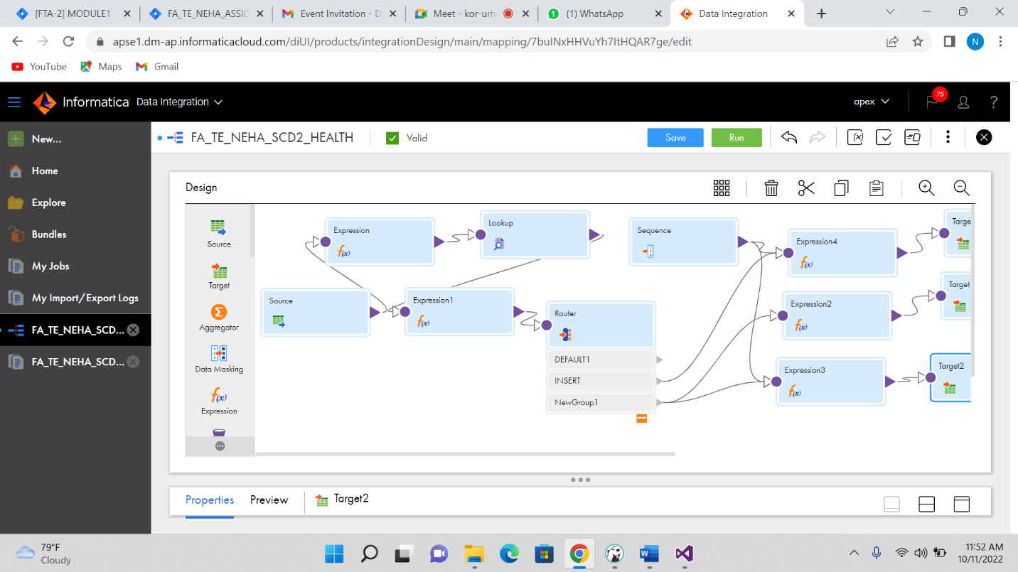

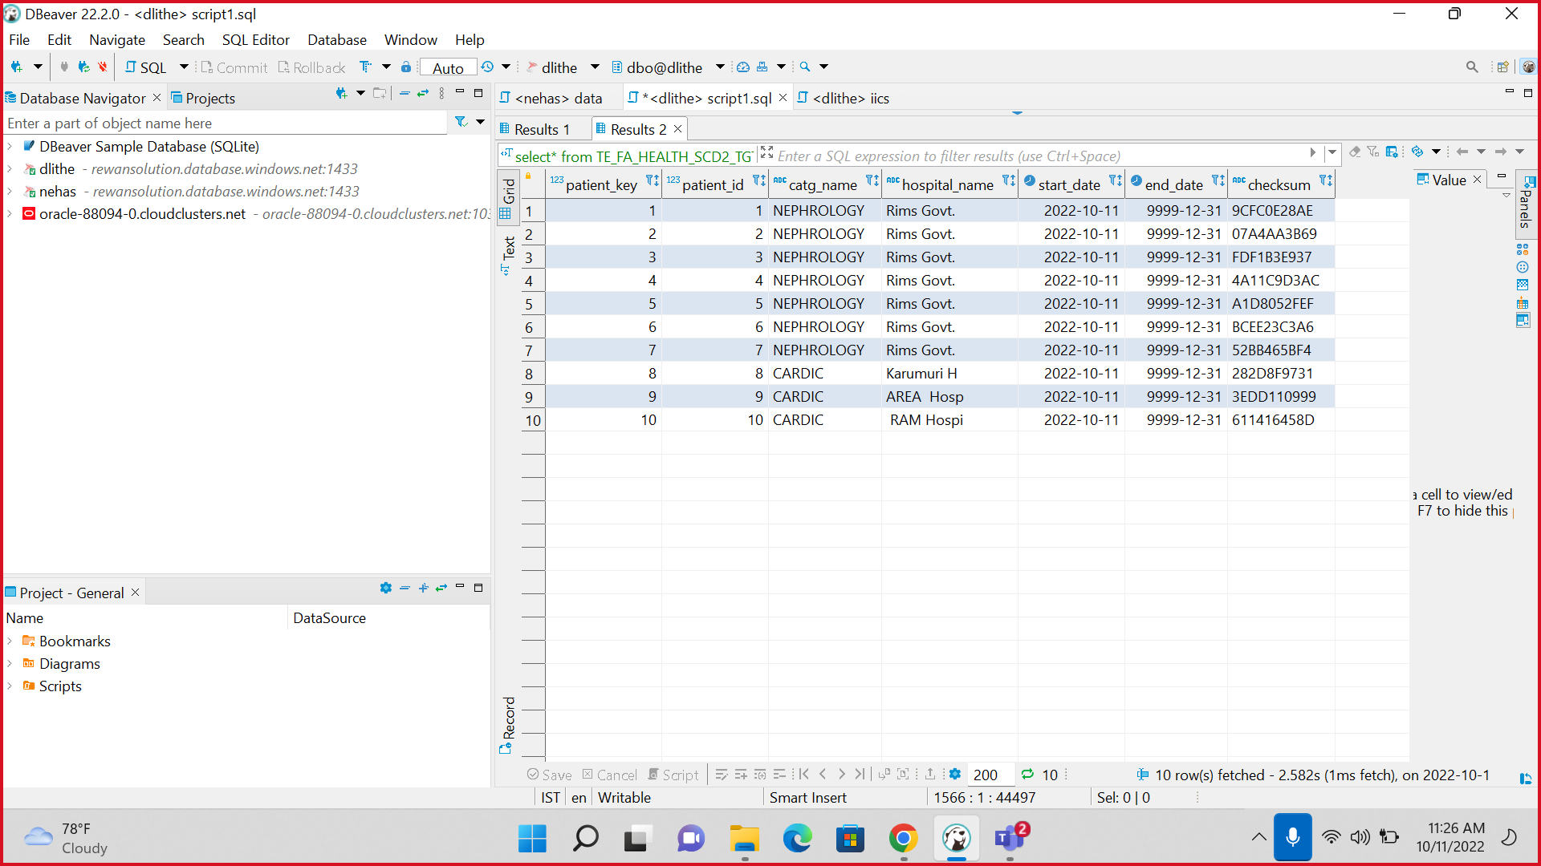

After updating output

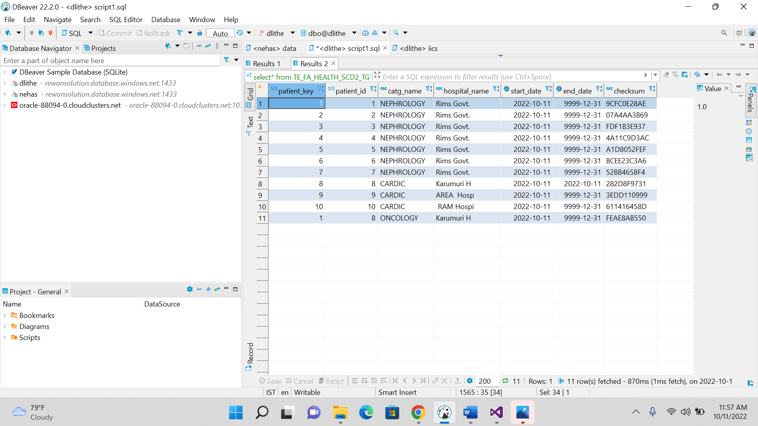

REPLICATION FUNCTION FOR TWO TABLE IN –ONE IS NA_ACCOUNT AND OTHER ONE IS NA_CONTACT

**create** **table** NA_account(

a_number **int**,

a_type **varchar**(50),

a_amount **float**,

);

**insert** **into** NA_account **values**(1000,'fixed',54556.5);

**insert** **into** NA_account **values**(1001,'current',50078.5);

**insert** **into** NA_account **values**(1002,'fixed',3456.9);

**insert** **into** NA_account **values**(1003,'fixed',11556.0);

**insert** **into** NA_account **values**(1004,'current',33336.0);

**insert** **into** NA_account **values**(1005,'fixed',55666.5);

**insert** **into** NA_account **values**(1006,'current',77776.5);

**create** **table** NA_contact(

c_name **varchar**(50),

c_age **int**,

c_number **varchar**(12),

)

**insert** **into** NA_contact **values**('neha',22,'56424570');

**insert** **into** NA_contact **values**('ram',21,'56000000');

**insert** **into** NA_contact **values**('shyam',20,'111114570');

**insert** **into** NA_contact **values**('gita',26,'99894570');

**insert** **into** NA_contact **values**('nita',23,'87904570');

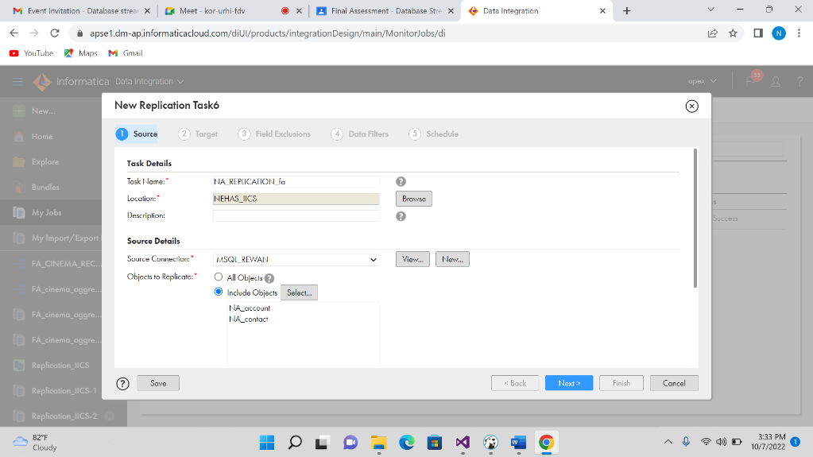

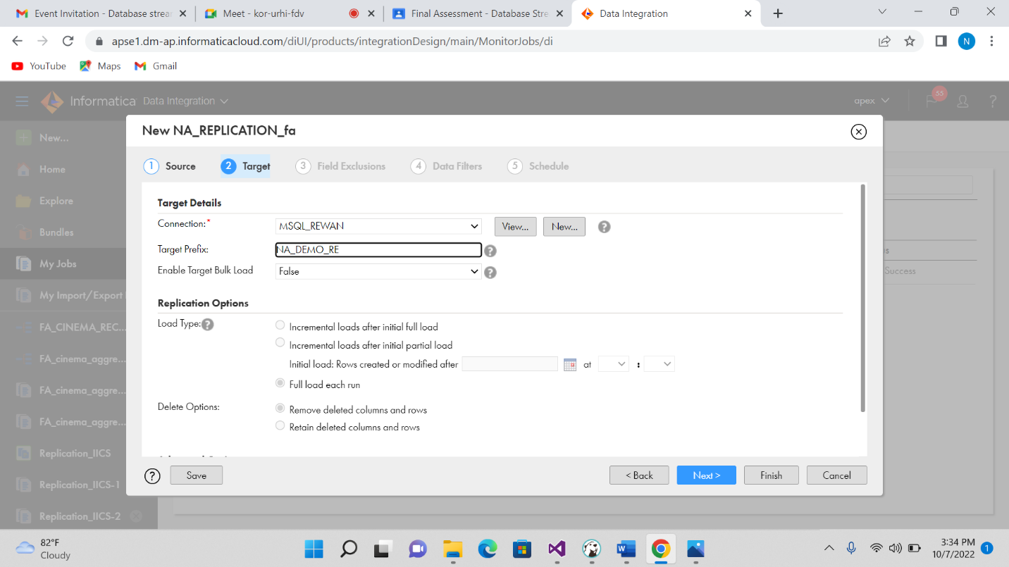

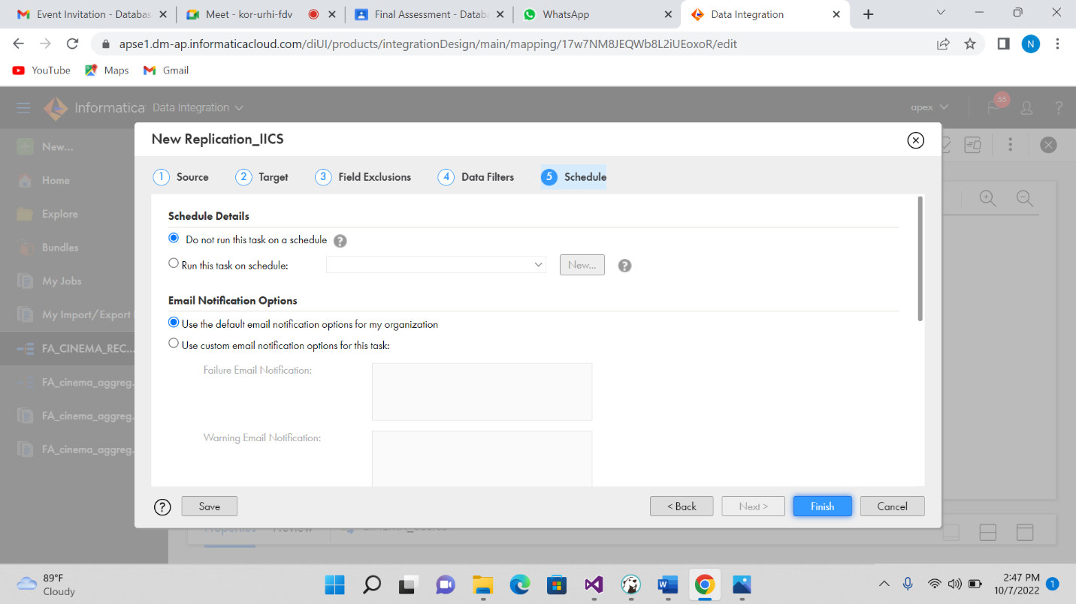

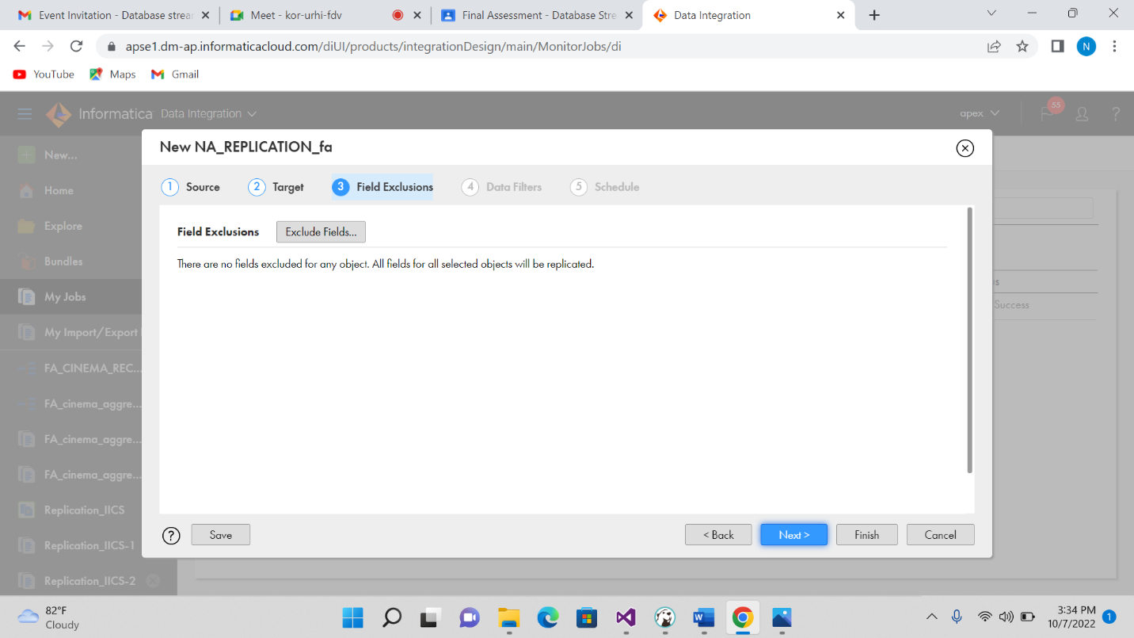

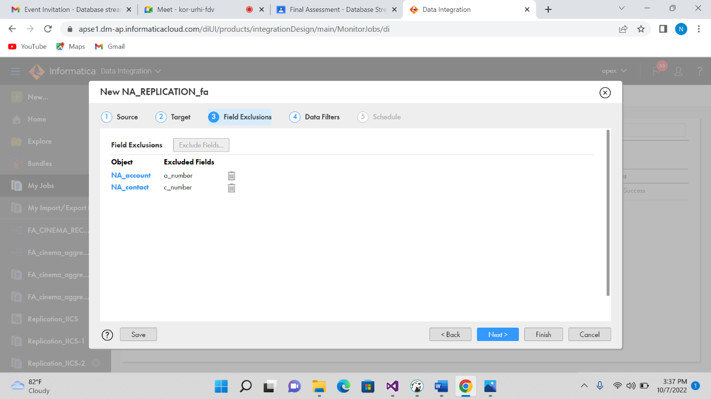

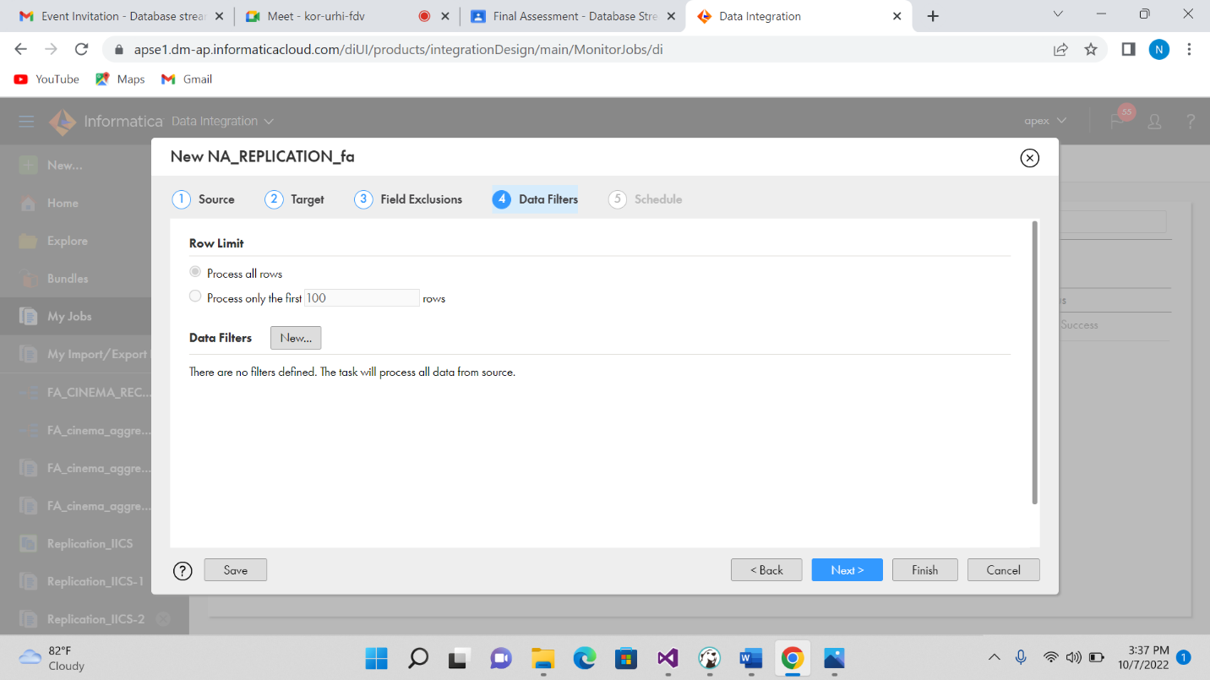

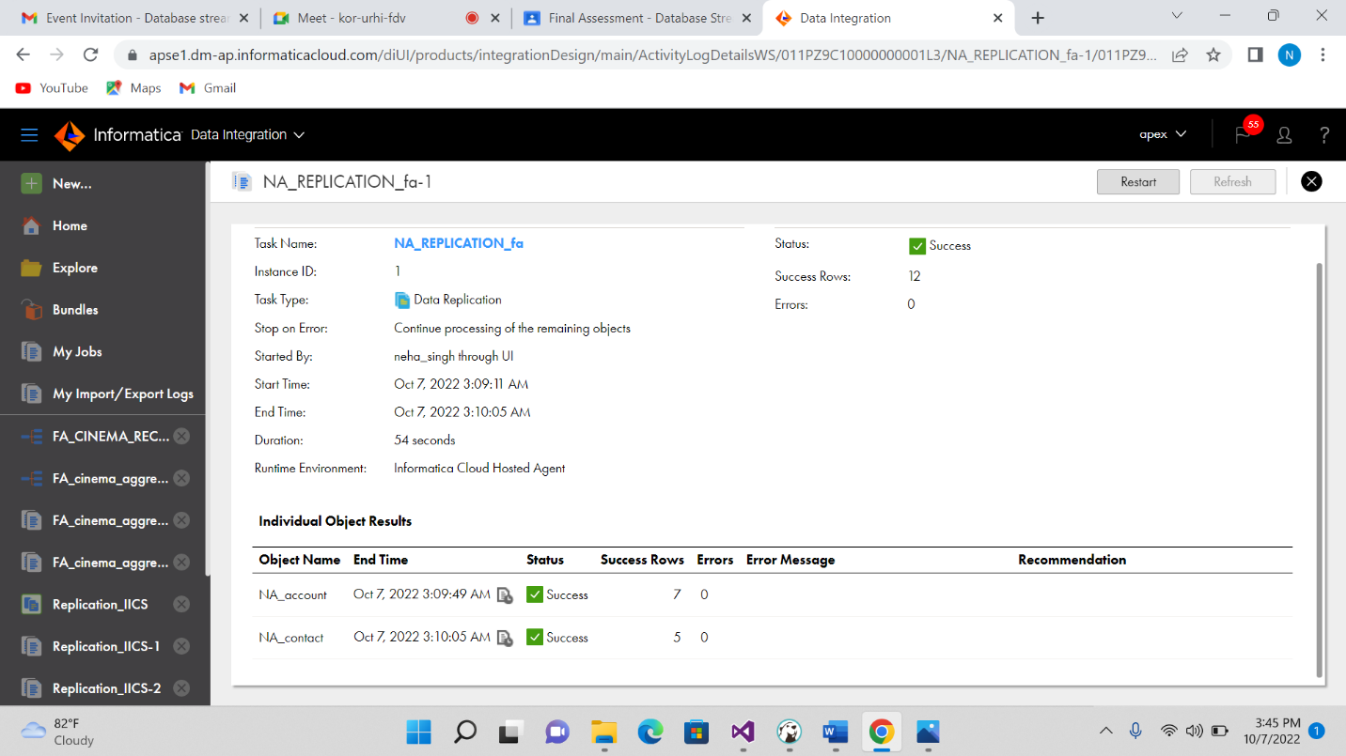

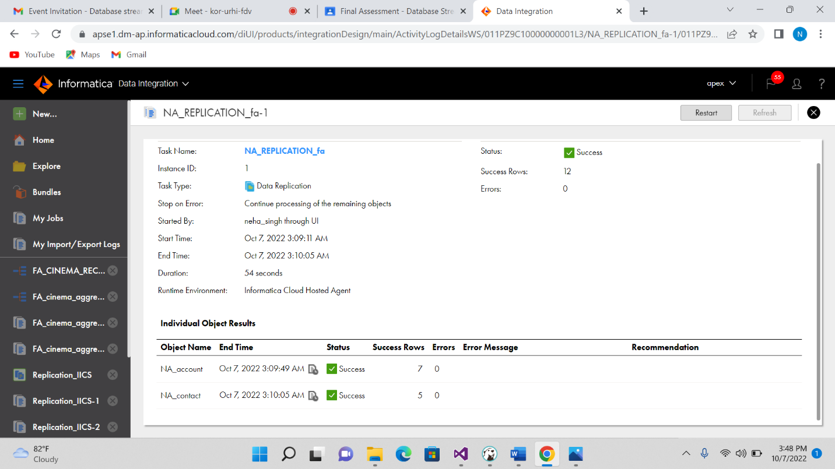

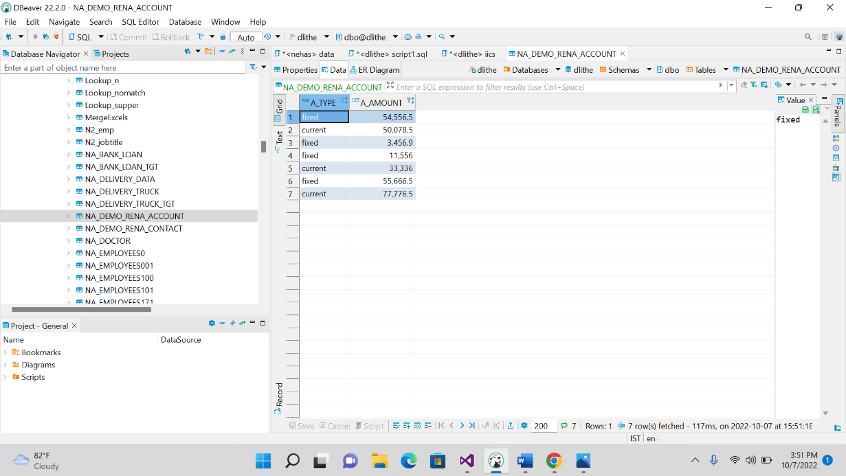

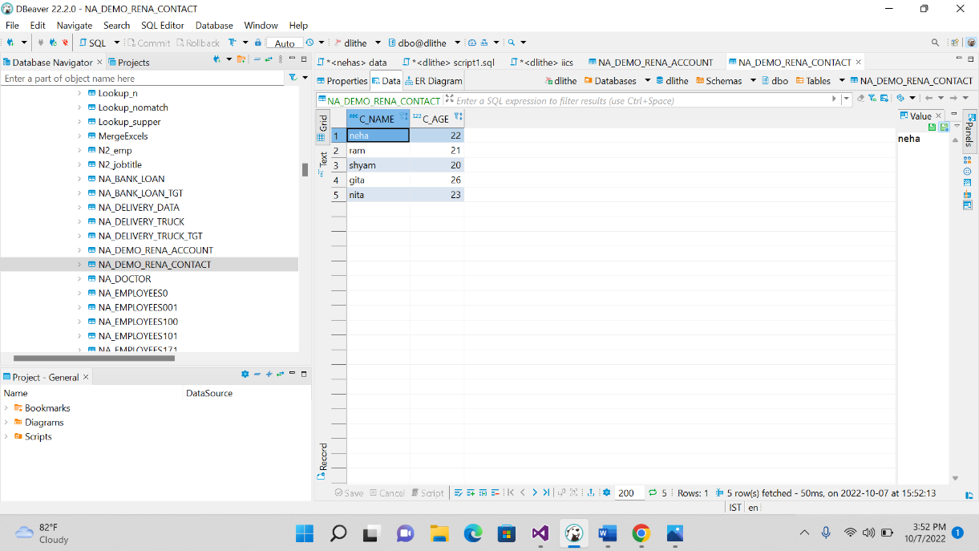

REPLICATION FUNCTION IN IICS

BY USING TABLE HOSPITAL,DOCTOR,PATIENT IN DLITHE SERVER

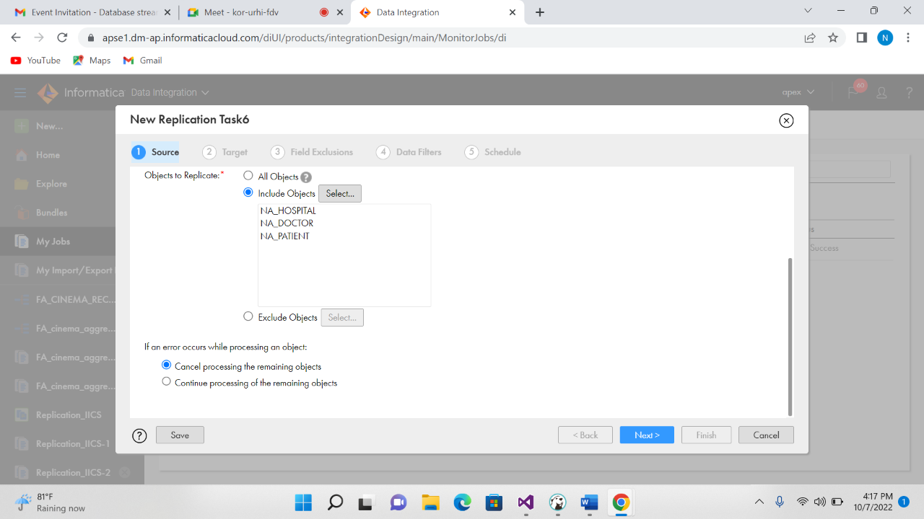

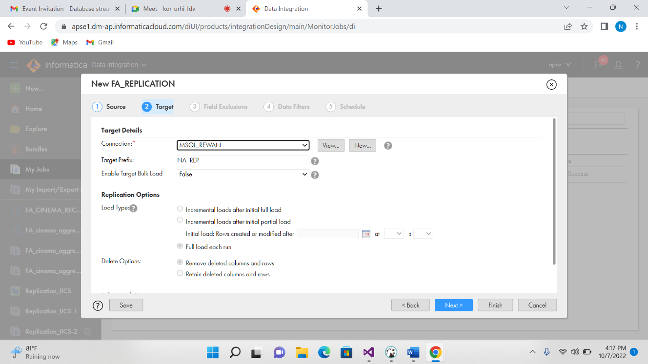

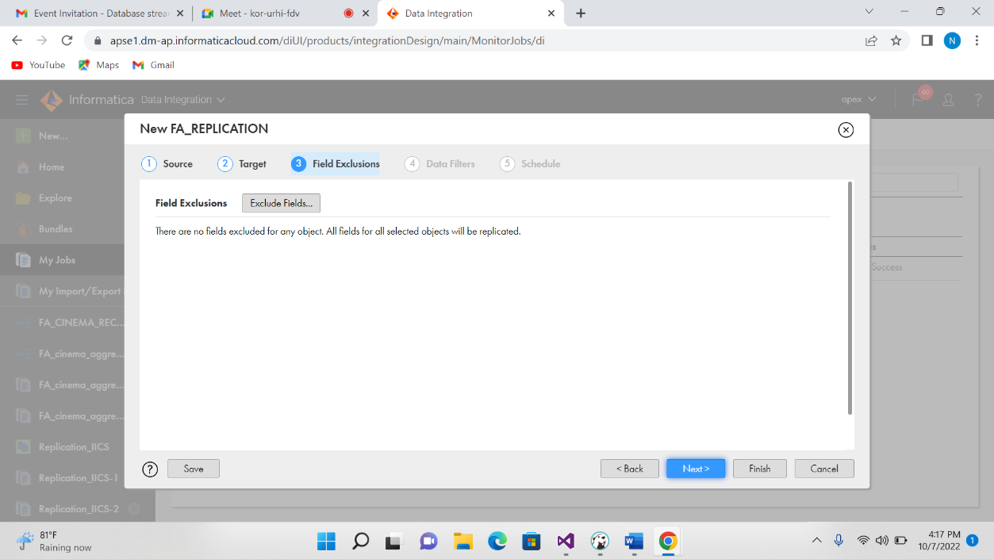

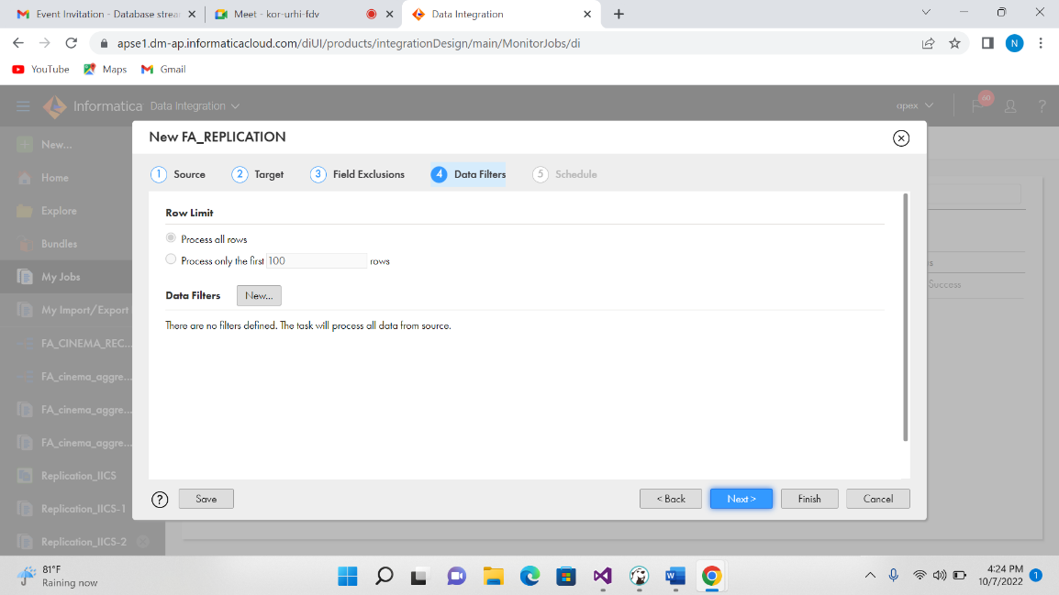

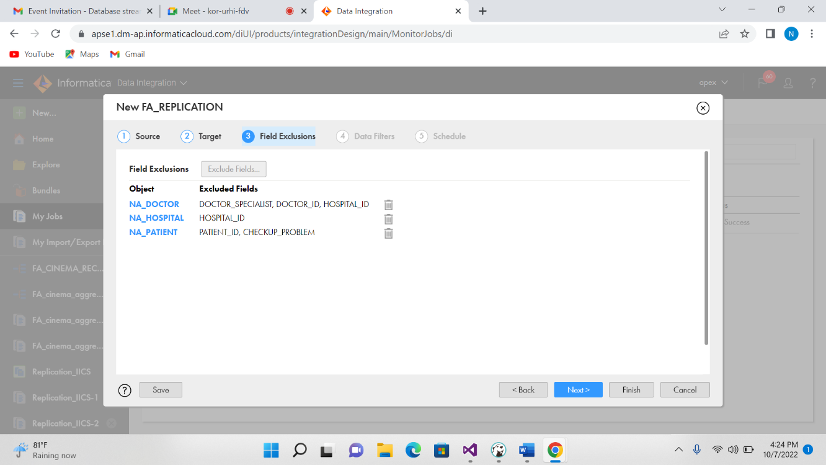

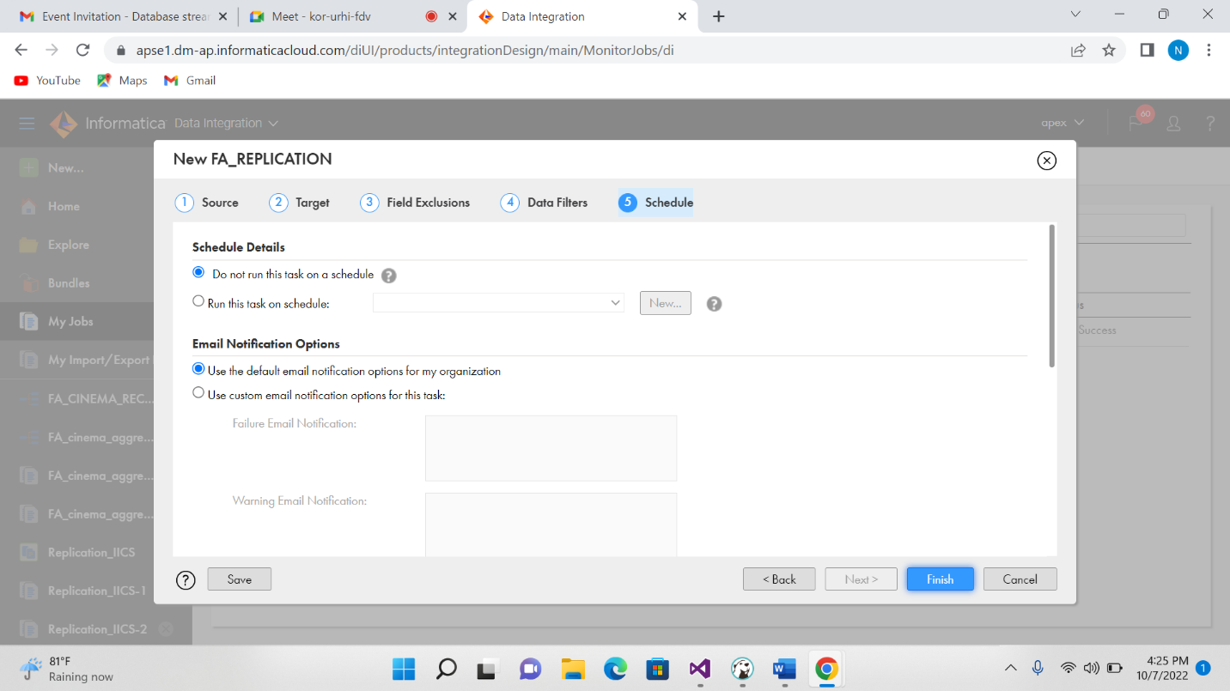

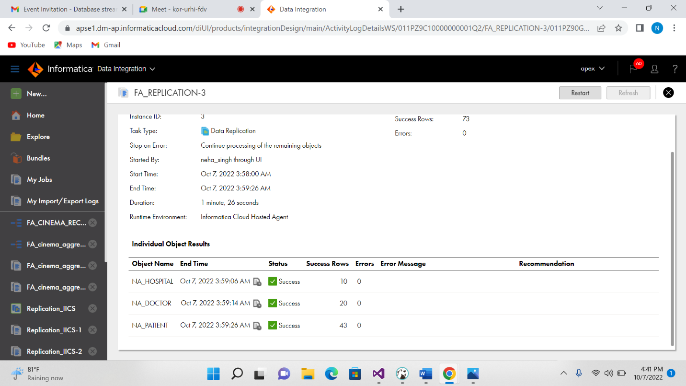

OUTPUT:

